The following is a daily plan of **suggested** work for your son. Your son will be very familiar with the format of the activities suggested to him. This is a great opportunity for your son to improve his skills of time management and independent work. If there are any questions about the work detailed please do not hesitate to email [4thdonacarney@gmail.com](mailto:4thdonacarney@gmail.com)

**Daily Plan**

*Monday 30th March*

**Maths** Mental Maths Wk 26 – Monday

Tables: Day 1

*Maths Word Problem* – Aaron starts watching a film at 2:20pm. The film is 85 minutes long. What time does the film end?

**English** Spellings: Block 89 and Exercise 1 and 2

Reading Zone. Unit 27 – Read Story.

Write red words into a story (can use red words more than once)

DEAR time for 15 minutes (Drop Everything and Read)

**Irish** Revise Irish verbs (should be in homework copy – don’t worry if you can’t find some or all of them. I will give them plenty of time when we get back to look over them)

Leigh sa Bhaile p84 (Read the poem and learn over the week)

**Exercise:** [Joe Wick's Workouts](https://www.youtube.com/channel/UCAxW1XT0iEJo0TYlRfn6rYQ)

***__________________________________________________________________________***

*Tuesday 31st March*

**Maths** Mental Maths Wk 26 – Tuesday

Tables: Day 2

*Maths Word Problem* – The side of a square measures 12 cm. How long is the perimeter?

**English** Spellings: Block 90 and Exercise 3

Reading Zone Unit 27 – Activity A and B

DEAR time 15 minutes

**Irish** Revise Irish verbs

Leigh sa Bhaile p84 (Read the poem and learn over the week)

**Exercise:** [Joe Wick's Workouts](https://www.youtube.com/channel/UCAxW1XT0iEJo0TYlRfn6rYQ)

**___________________________________________________**

*Wednesday 1st April*

**Maths** Mental Maths Wk 26– Wednesday

Tables: Day 3

*Maths Word Problem* – Molly has a piece of string that is 75cm long. She cuts the string into 3 **equal** lengths. How long is one length of string?

**English** Spellings: Block 91 and Exercise 4

Reading Zone Unit 27 – Activity C and D

DEAR time 15 minutes

**Irish** Revise Irish verbs

Leigh sa Bhaile p84 (Read the poem and learn over the week)

**Exercise:** [Joe Wick's Workouts](https://www.youtube.com/channel/UCAxW1XT0iEJo0TYlRfn6rYQ)

**Religion:** View the [Easter Story](https://www.youtube.com/watch?v=0PSgoPdKQFQ) and make a written note of the important events in the story.

***__________________________________________________________________________***

*Thursday 2nd April*

**Maths** Mental Maths Wk 26 – Thursday

Tables: Day 4

*Maths Word Problem* – Ellie buys a teddy for €6.10 and a pair of rollerblades for €8.20. How much does she spend overall?

**English** Spellings Block 92 and Exercise 5 and 6

Reading Zone Unit 27 – Activity E and F

DEAR time 15 minutes (Drop Everything And Read)

**Irish** Revise Irish verbs

Leigh sa Bhaile p84 (Read the poem and learn over the week)

**Exercise:** [Joe Wick's Workouts](https://www.youtube.com/channel/UCAxW1XT0iEJo0TYlRfn6rYQ)

**Religion:** View the [Easter Story](https://www.youtube.com/watch?v=0PSgoPdKQFQ) and sequence (put in order) the story using pictures. Draw these pictures yourself and give each picture a title. For example, Here is Jesus and his disciples at the Last Supper.

***_________________________________________________________________***

*Friday 3rd April*

**Maths** Mental Maths Wk 26 – Friday and Problem Solving

Tables: Test yourself

**English** Spellings: Test yourself!

Reading Zone Unit 27 – Activity G

Choose any **ten** spellings from this week’s list and write each into a sentence.

DEAR time 15 minutes (Drop Everything And Read)

**Irish** Revise Irish verbs

Say the Irish poem out loud to your family (Leigh sa Bhaile p84)

**Exercise:** [Joe Wick's Workouts](https://www.youtube.com/channel/UCAxW1XT0iEJo0TYlRfn6rYQ)

**Science:** Look up facts about the Giraffe and write a fact file about the animal. An example of a fact file is found in the resources section below.

Complete the cloze procedure about the Giraffe (found in resources section below).

_________________________________________________________________

**Resources:**

**Giraffe Fact File:**

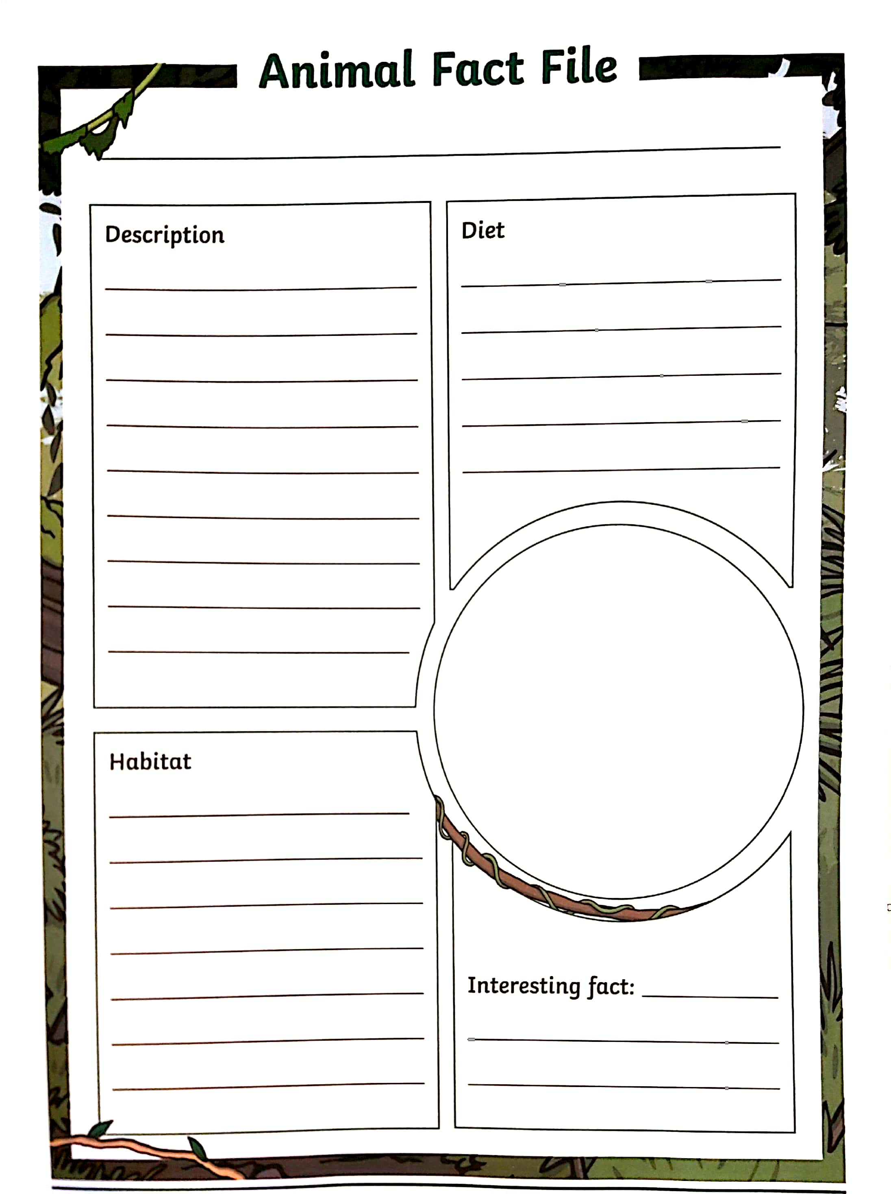

**Giraffe Cloze Procedure:**

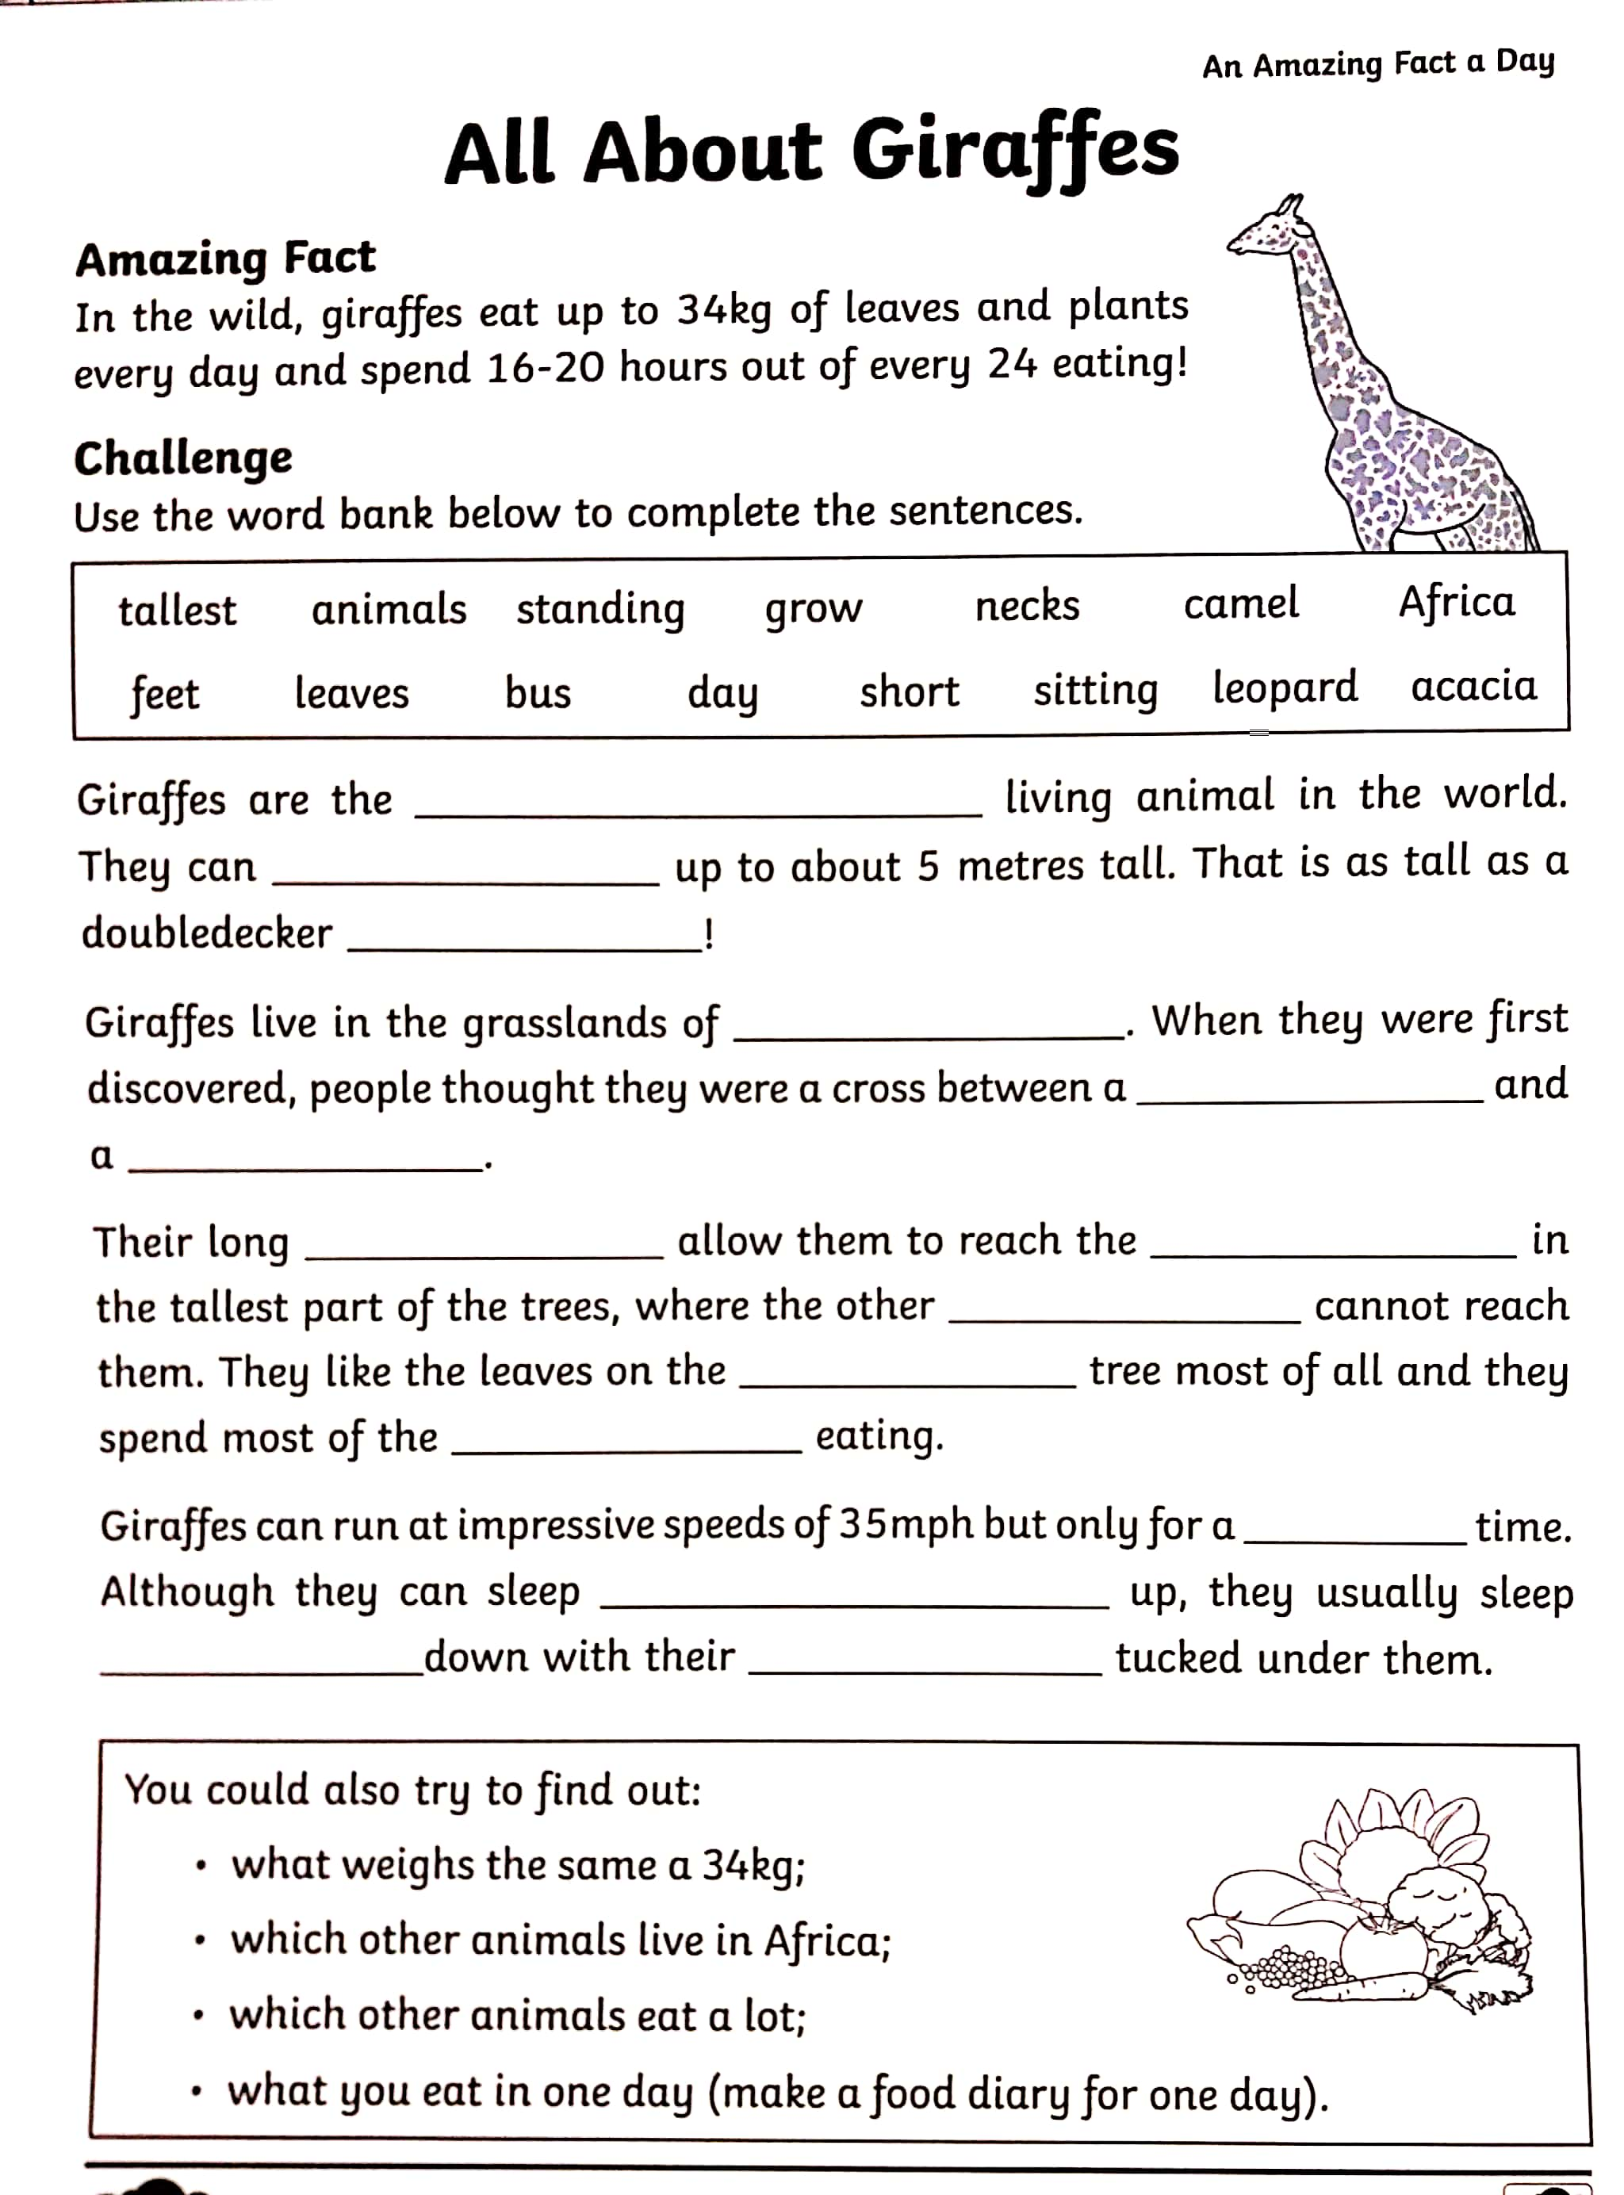

**Giraffe Cloze Procedure Answers:**

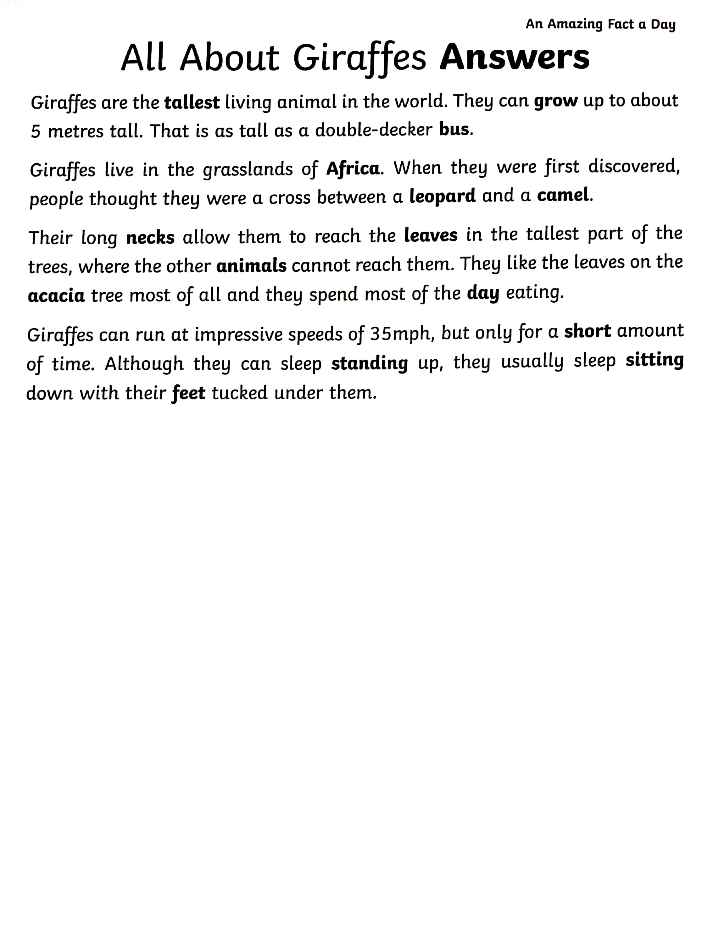

**Spellings Sheets**

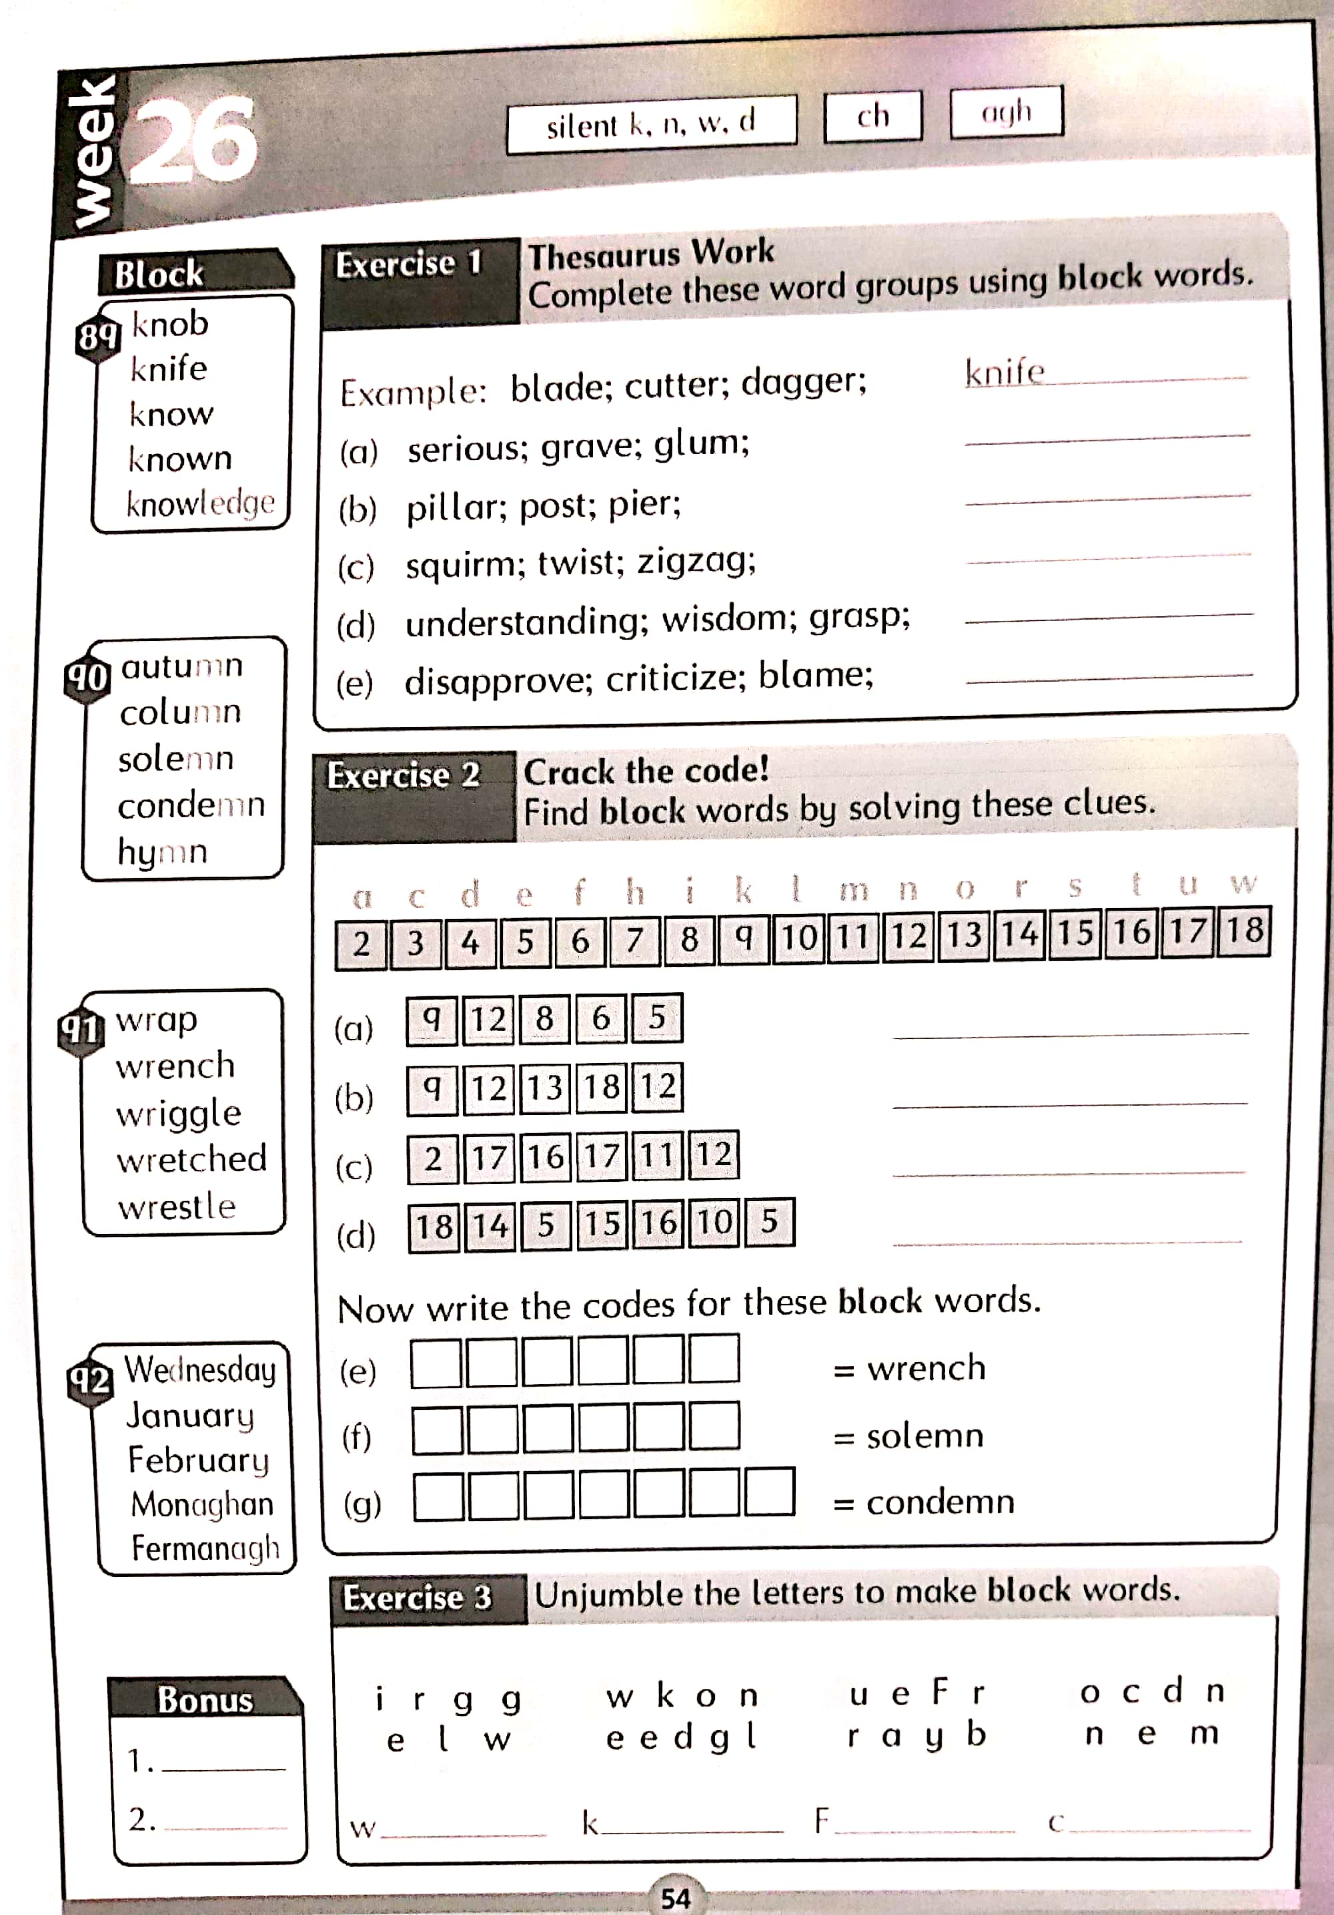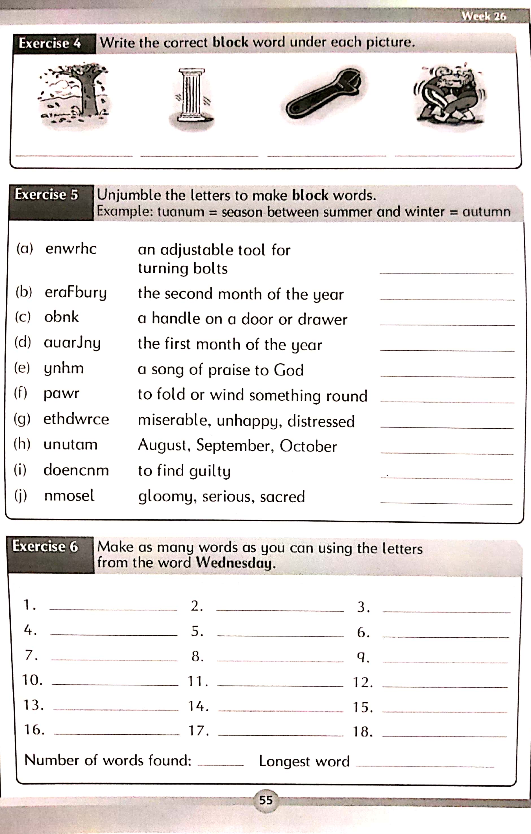

**Table Maths Sheets**

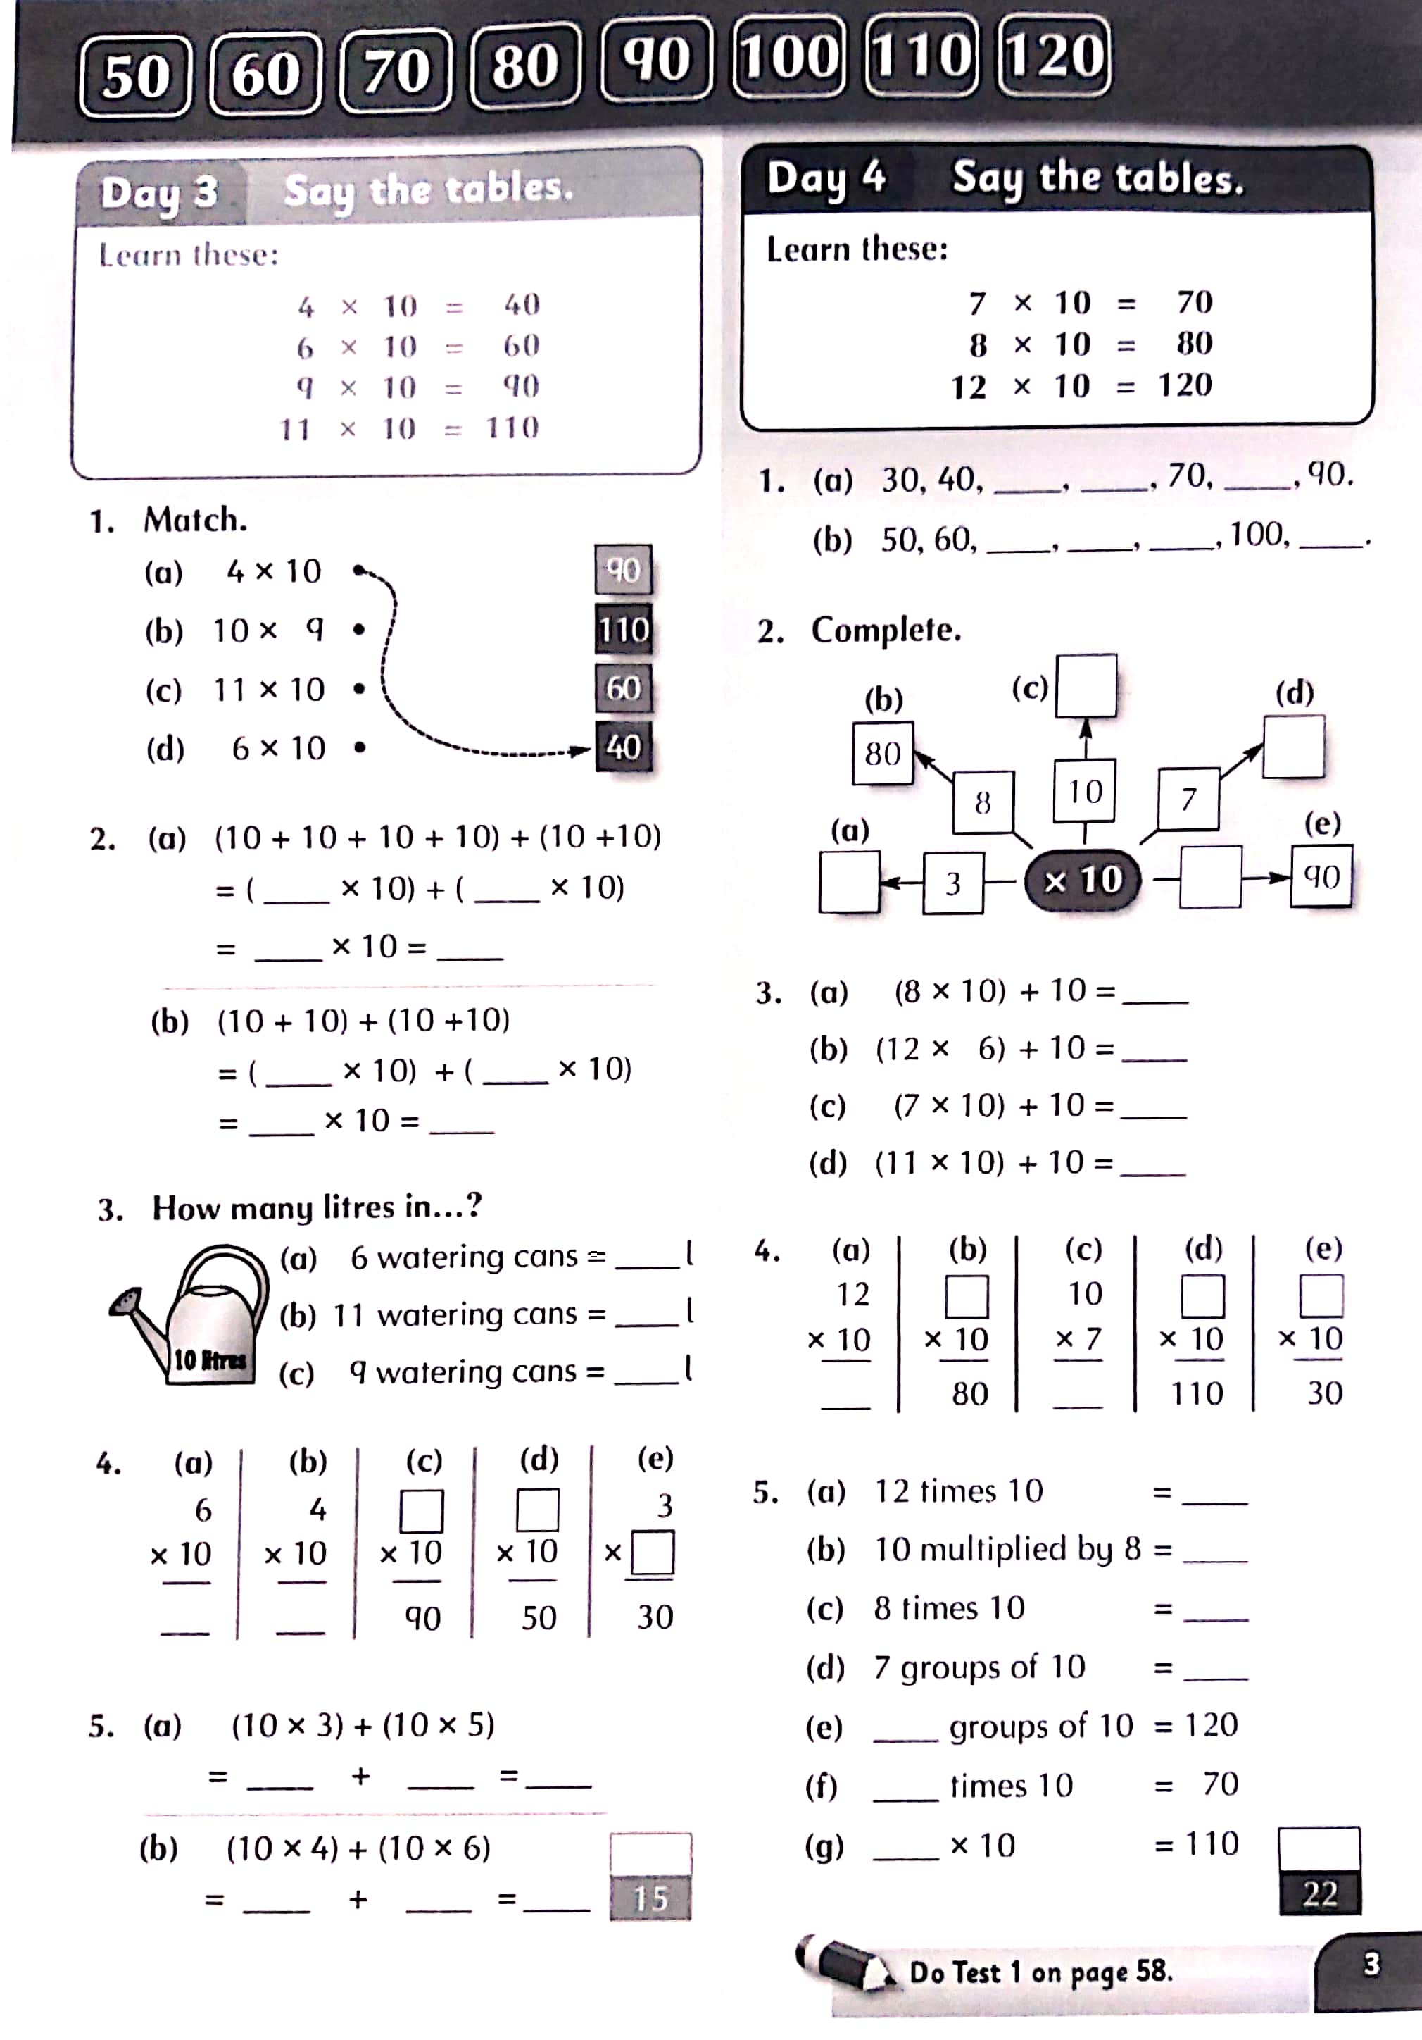

**Religion Resources Links (Holy Week):**

[Religion Comprehension](cfe-re-311-all-about-holy-week-differentiated-reading-comprehension-activity-english_ver_2.pdf) and [Last Supper Powerpoint](T-T-19245-The-Last-Supper-Story-PowerPoint_ver_1.ppt)

**Mental Maths Answers for the week:**

|  |  |  |  |  |  |
| --- | --- | --- | --- | --- | --- |
| Monday | Tuesday | Wednesday | Thursday | Friday | Problem Solving |
| Q1. 2, 674 | Q1. 35 | Q1. 74 days | Q1. 7x30 | Q1. 65 days | ***Monday*** |
| Q2. 7 | Q2. 80 cm | Q2. €26 | Q2. 293 | Q2. €30 each | Q1. Adult Check |
| Q3. €10 | Q3. 17 | Q3. €16.20 | Q3. 2,350 | Q3. €15 each | Q2. 40 |
| Q4. €5 | Q4. 10.8 | Q4. 120 | Q4. 130cm | Q4. Rectangle |  |
| Q5. 130 | Q5. 150 | Q5. 48 cm | Q5. 2:50 | Q5. 80 | ***Tuesday*** |
| Q6. 230 | Q6. 1.0 | Q6. 8 | Q6. 69 | Q6. 5 | Q1. Guitar |
| Q7. 4km 5m | Q7. vertical | Q7. 7 hours 30 minutes | Q7. 110 | Q7. 400 | Q2. 15 pupils |
| Q8. 7,000+700+50+5 | Q8. Rhombus | Q8. Isosceles | Q8. 125 | Q8. 63 |  |
| Q9. Adult check | Q9. 40 | Q9. 7km 90m | Q9. 6.9kg | Q9. 1.5 | ***Wednesday*** |
| Q10. 28 | Q10. 69.9kg | Q10. Square | Q10. Hexagon | Q10. 160 | Q1. C A B |
| Q11. No | Q11. 0.49 | Q11. 5 | Q11. 36 | Q11. €21 | Q2. 2.20 sec |
| Q12. True | Q12. 4 L 50ml | Q12. 3,065 | Q12. 0.5 | Q12. 6km 8 m |  |
| Q13. 6 hours 15 minutes | Q13. 12:40 | Q13. 6/8 | Q13. 25 cm | Q13. 160 | ***Thursday*** |
| Q14. 0.7 | Q14. 6 | Q14. 280 | Q14. 4 in 4 | Q14. Horizontal | Q1. €20 |
| Q15. 15÷6=5 | Q15. 82 | Q15. 12 | Q15. 350 | Q15. 7th January | Q2. 79 |
| Q16. 34 | Q16. 72 | Q16. €45÷9=€5 | Q16. 7 L 999ml | Q16. 4 hours 20 minutes |  |
| Q17. Circle | Q17. 20 | Q17. 2.1 | Q17. €19.20 | Q17. 75 |  |
| Q18. 25th December | Q18. You will go to bed tonight | Q18. 0.2 | Q18. 54 | Q18. €30÷10=€3 |  |
| Q19. 17 | Q19. 300 | Q19. 35 | Q19 Horizontal | Q19. Adult check |  |
| Q20. 86 | Q20. 8/10 | Q20. 200 | Q20. 7,057 | Q20 68 |  |
|  |  |  |  | Q21. 2,110 |  |
|  |  |  |  | Q22. 150 |  |
|  |  |  |  | Q23. 60cm |  |
|  |  |  |  | Q24. 72.9kg |  |
|  |  |  |  | Q25. 4 L 90ml |  |