The following is a daily plan of suggested work for your son. All worksheets will be found at the end of this document. If there are any questions about the work detailed please do not hesitate to email 4thdonacarney@gmail.com.
Monday 18th May
Maths Mental Maths Wk 31– Monday
Tables: Day 1
Maths Word Problem – Gran gives Callum €25 for his birthday. His mom gives him half the amount that Gran gives him. How much does he get altogether?
Test 1 (General Revision) – Worksheet found below in resources section.
English
- Spellings: Week 31 Block 109 and Exercise 1
- Comprehension activity ‘The Dolphin Mystery’ – Read the story
- Pick out any words that you did not understand and look them up in the dictionary. Does the sentence make sense now?
- DEAR time 15 minutes
Irish
- Revise Irish verbs in your homework copy and learn new verb (Caill – to lose)
- Leigh sa Bhaile p92 – Leigh an scéal (Read the story). Use your dictionary to figure out any words you do not know. If you need any help please ask your parent to email me!
Exercise: Joe Wick's Workouts
OR
Try and pick three activities from the poster.

_________________________________________________
Tuesday 19th May
Maths Mental Maths Wk 31– Tuesday
Tables: Day 2
Maths Word Problem – Fourth class go to the cinema. Adult tickets cost €1.20. Children tickets cost 50c. What is the total cost for 20 children and 5 adults?
English
- Spellings: Week 31 Block 110 and Exercise 2 and 3
- ‘The Dolphin Mystery’- Activity 1, 2 and 3 page 24
- DEAR time 15 minutes
Irish:
- Revise Irish verbs in your homework copy. Learn new verb (Caill).
- Leigh sa Bhaile p92. Freagair na ceisteanna 1-5 (Answer the questions)
Geography:
Trees – Deciduous vs. Evergreen. Fill out the worksheets below in the resource section to your best ability. Explore the trees around you. What characteristics do they have? Do they flower? Do they have seeds? Enjoy the activity of bark rubbing.
Exercise: Joe Wick's Workouts
OR
Try and pick three activities from the poster.

__________________________________________________________________________
Wednesday 20th May
Maths Mental Maths Wk 31 – Wednesday
Tables: Day 3
Maths Word Problem – In a traffic survey, 4th class count 6 red cars and 16 white cars. There were half as many blue cars as white. There were three times more black cars than blue. How many cars altogether?
Test 2 (General Revision) – worksheet found below in resource section.
English
- Spellings: week 31 Block 111 and Exercise 4
- ‘The Dolphin Mystery’ – Page 25 Activity 1
- Noun hunt – Fill in the worksheet below in resource section. Remember, a noun is a person, place or thing. E.g. Mr Culligan, garden, tree – these are all nouns.
- DEAR time (Drop everything and read) for 15 minutes.

Irish
- Revise Irish verbs in your grammar copy. Learn new verb (Caill)
- Leigh sa Bhaile lth. 93 – Leigh an scéal (Read the story)
SPHE:
It is important that we are being kind to ourselves and one way to do this is to create a ‘self-care’ plan. I have attached an example layout below in the resources section but you can create a self-care plan to suits you best. If you find watching a movie helps you relax and give your mind a rest then list 5 movies you would like to see. The same can be said for if art/cooking/baking/exercise/games help you to relax. Make this self-care plan suit YOU.
Exercise: Joe Wick's Workouts OR
Try and pick three activities from the poster.

_________________________________________________________________
Thursday 21st May
Maths Mental Maths Wk 31 – Thursday
Tables: Day 4
Maths Word Problem – A box of chocolate bars contains 6 bars and costs €1.80. How much is the cost of ONE chocolate bar?
English
Spellings: Week 31 Block 112 and Exercise 5
The Dolphin Mystery – page 25 Activity 2 and 3
DEAR time 15 minutes.
Poem – ‘The Tree In Season’ by Robert Fisher – Read this poem out loud to your family. Make sure to go over it a few times yourself. Notice your voice, shoulder’s back, good eye contact and keep the poem page at chest level. Good luck 😊
Irish
- Revise Irish verbs in your grammar copy. Learn new verb (Caill)
- Leigh sa Bhaile lth. 93 – Freagair na ceisteanna (Answer the questions)

Science: - The Bee.
- Since we are seeing the bumble bee and wasps around a lot more these days, it would be nice to create a fact file on them. I have attached a Bee outline for you below that you can fill with interesting facts about the Bee.
Exercise: Joe Wick's Workouts OR
Try and pick three activities from the poster.

_______________________________________________________________
Friday 22nd May
Maths Mental Maths Wk 31 –Friday test and problem solving
Tables: Ask a family member to test you
English
- Spellings: Ask a family member to test you on this week’s spellings “Week 31”
- Write a story about anything you would like and try to put in at least 10 of this week’s spelling words. Underline the words in your story.
- DEAR time (Drop Everything and Read) 15 minutes
Irish
- Verb revision: Fill in the blanks with the correct verb.
- ____(he lost) a leabhar.
- ____(They will lose) an cluiche amárach.
- ____(I lost) mo pheann.
- ____ (she loses) a heochracha gach lá.
- Ask a family member to test you on all 3 tenses of this week’s verb (Caill)
Science Experiment:
Click on the following link to check out this week’s science experiment at home. Have you ever made a rubber egg before? If not, have a look and try it out.
Have fun!
https://www.metrofamilymagazine.com/simple-science-experiment-the-rubber-egg/
Exercise: Joe Wick's Workouts OR
Try and pick three activities from the poster.

Resources

Irish Verbs Chart:
Ordú | Inné | Gach Lá | Amárach
Tóg (take/build) | Thóg (took) | Tógann (take) | Tógfaidh (will take)
Dún (close) | Dhún (closed) | Dúnann (close) | Dúnfaidh (will close)
Glan (clean) | Ghlan (cleaned) | Glanann (clean) | Glanfaidh (will clean)
Díol (sell) | Dhíol (sold) | Díolann (sell) | Díolfaidh (will sell)
Gearr(cut) | Ghearr (cut) | Gearrann (cut) | Gearrfaidh (will cut)
Caill (lost) | Chaill (lost) | Cailleann (lose) | Caillfidh (will lose)

Notice that the past tense is in red, present tense or every day is in yellow and the future tense is in blue. Remember that the word ‘Ordú’ basically means the root word or base word. Don’t forget that all of the words in colour above can be used with:
Examples
mé -> Dhíol mé (I sold)
tú -> Dhún tú (you closed)
sé -> Chaill sé (he lost)
sí -> Díolann sí (she sells)
sinn -> Caillimid (we lose)
sibh -> Glanann sibh (you plural/ye clean)
siad -> Chaillfidh siad (They will lose)

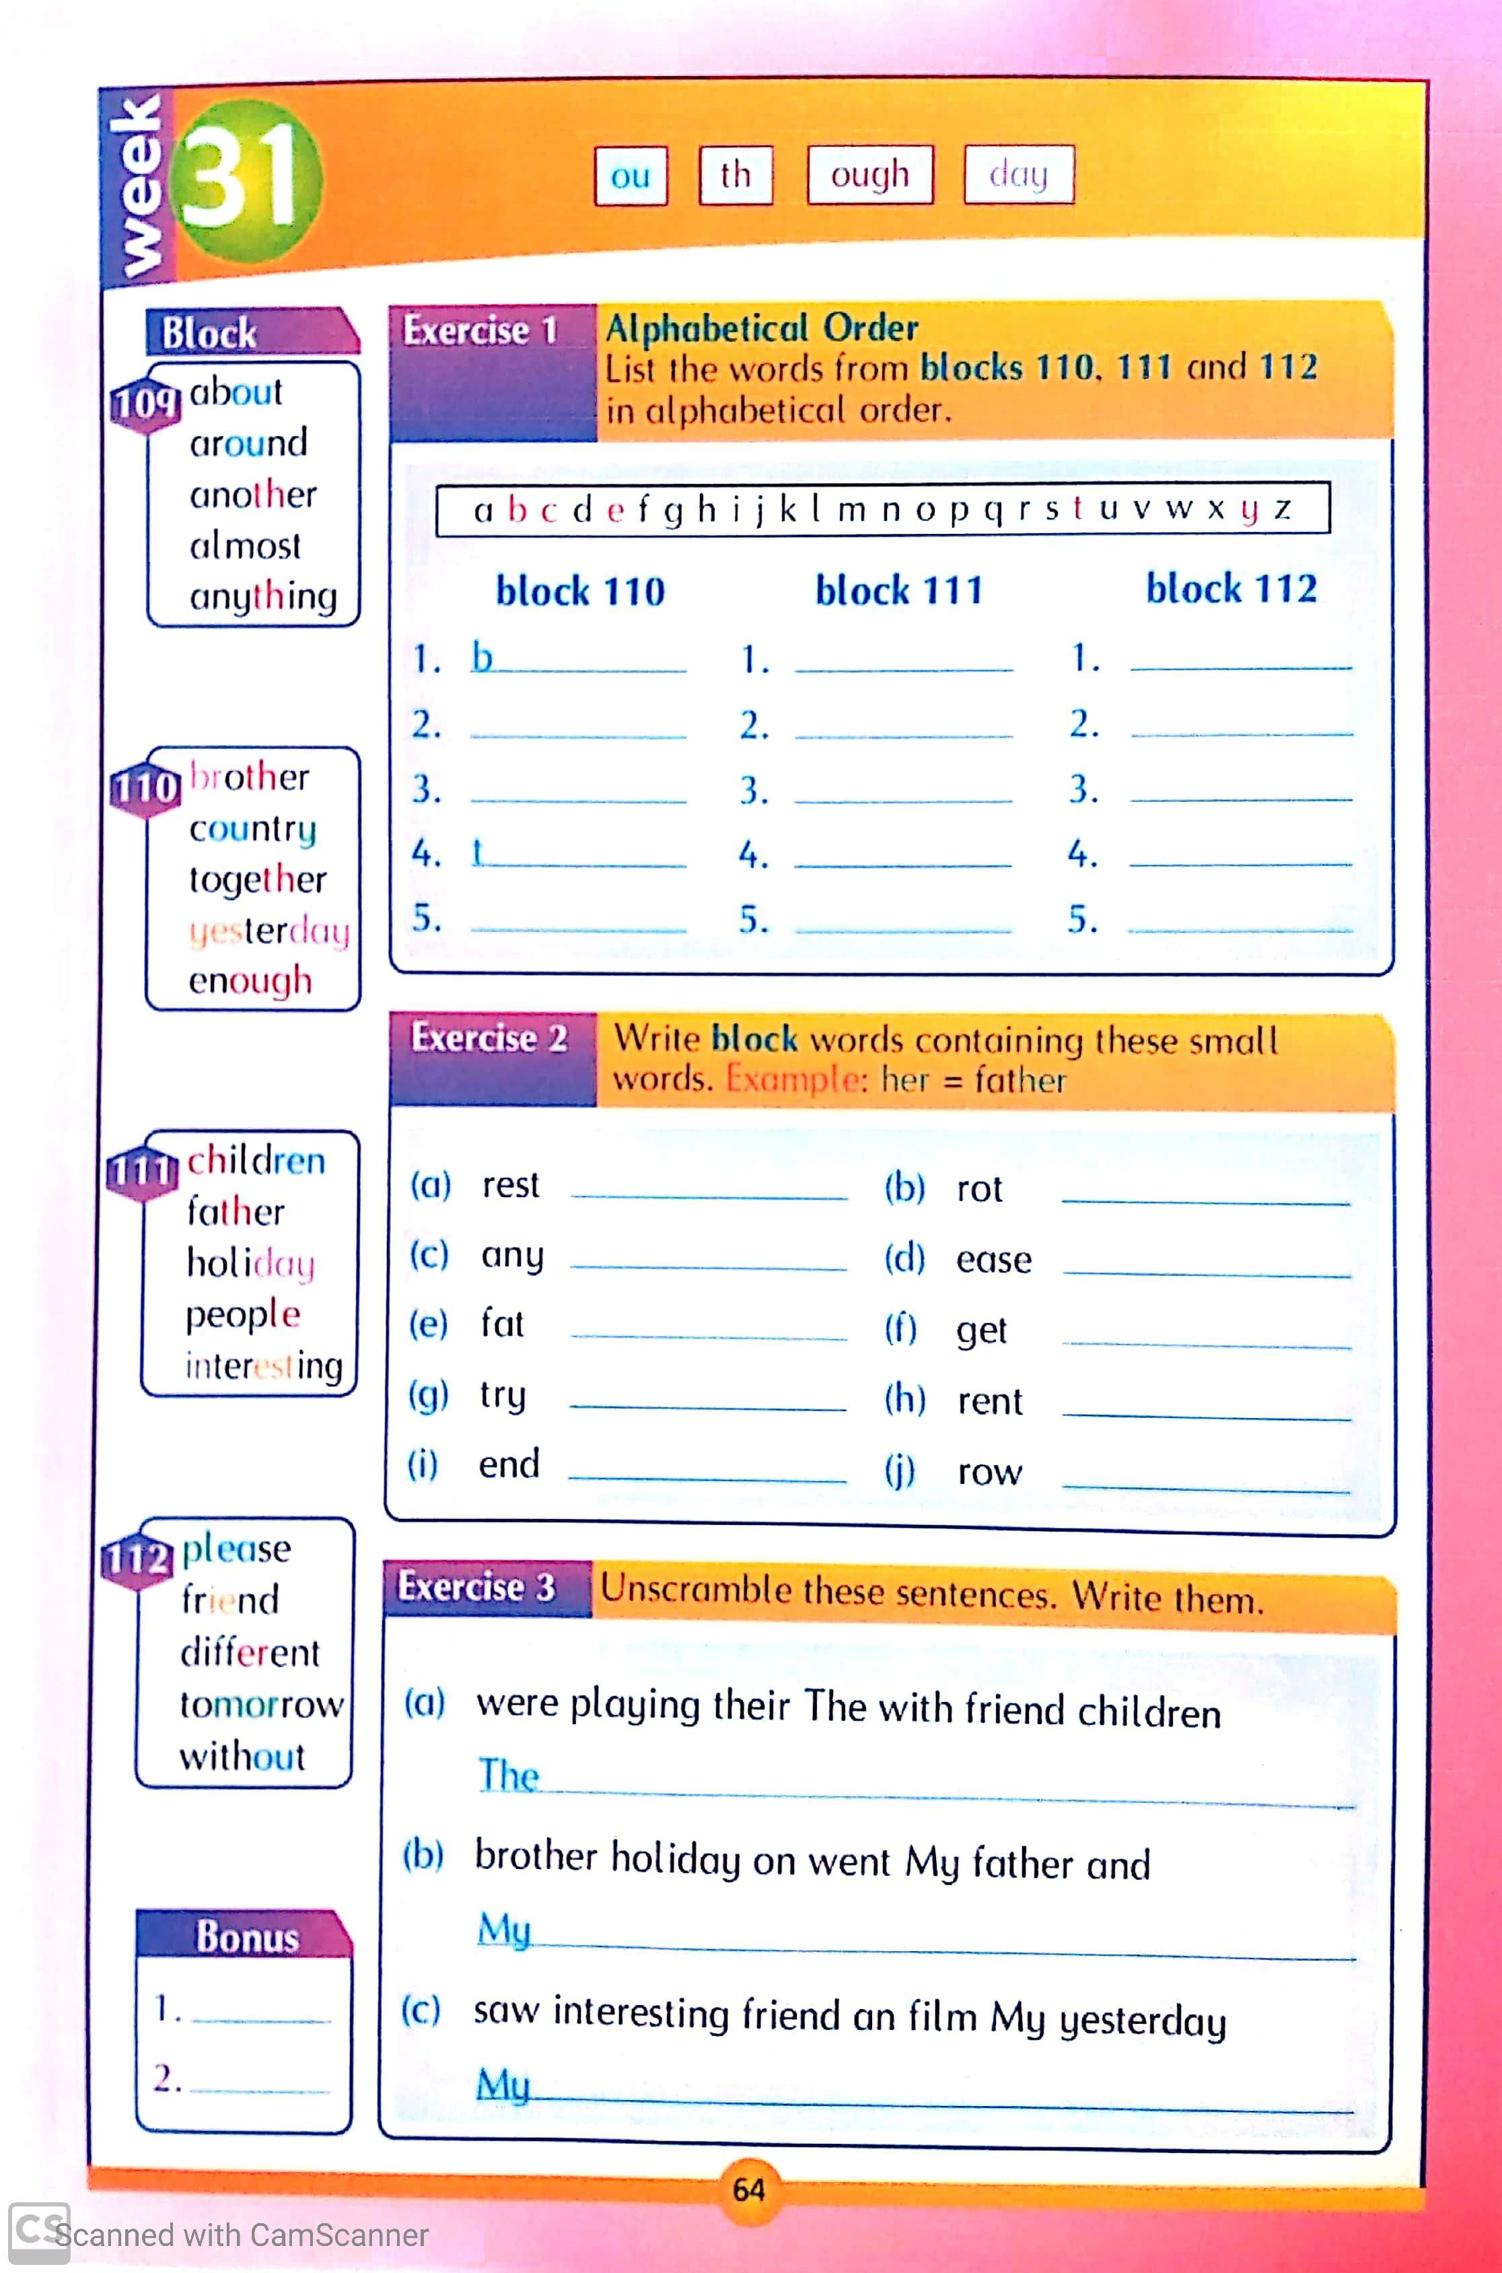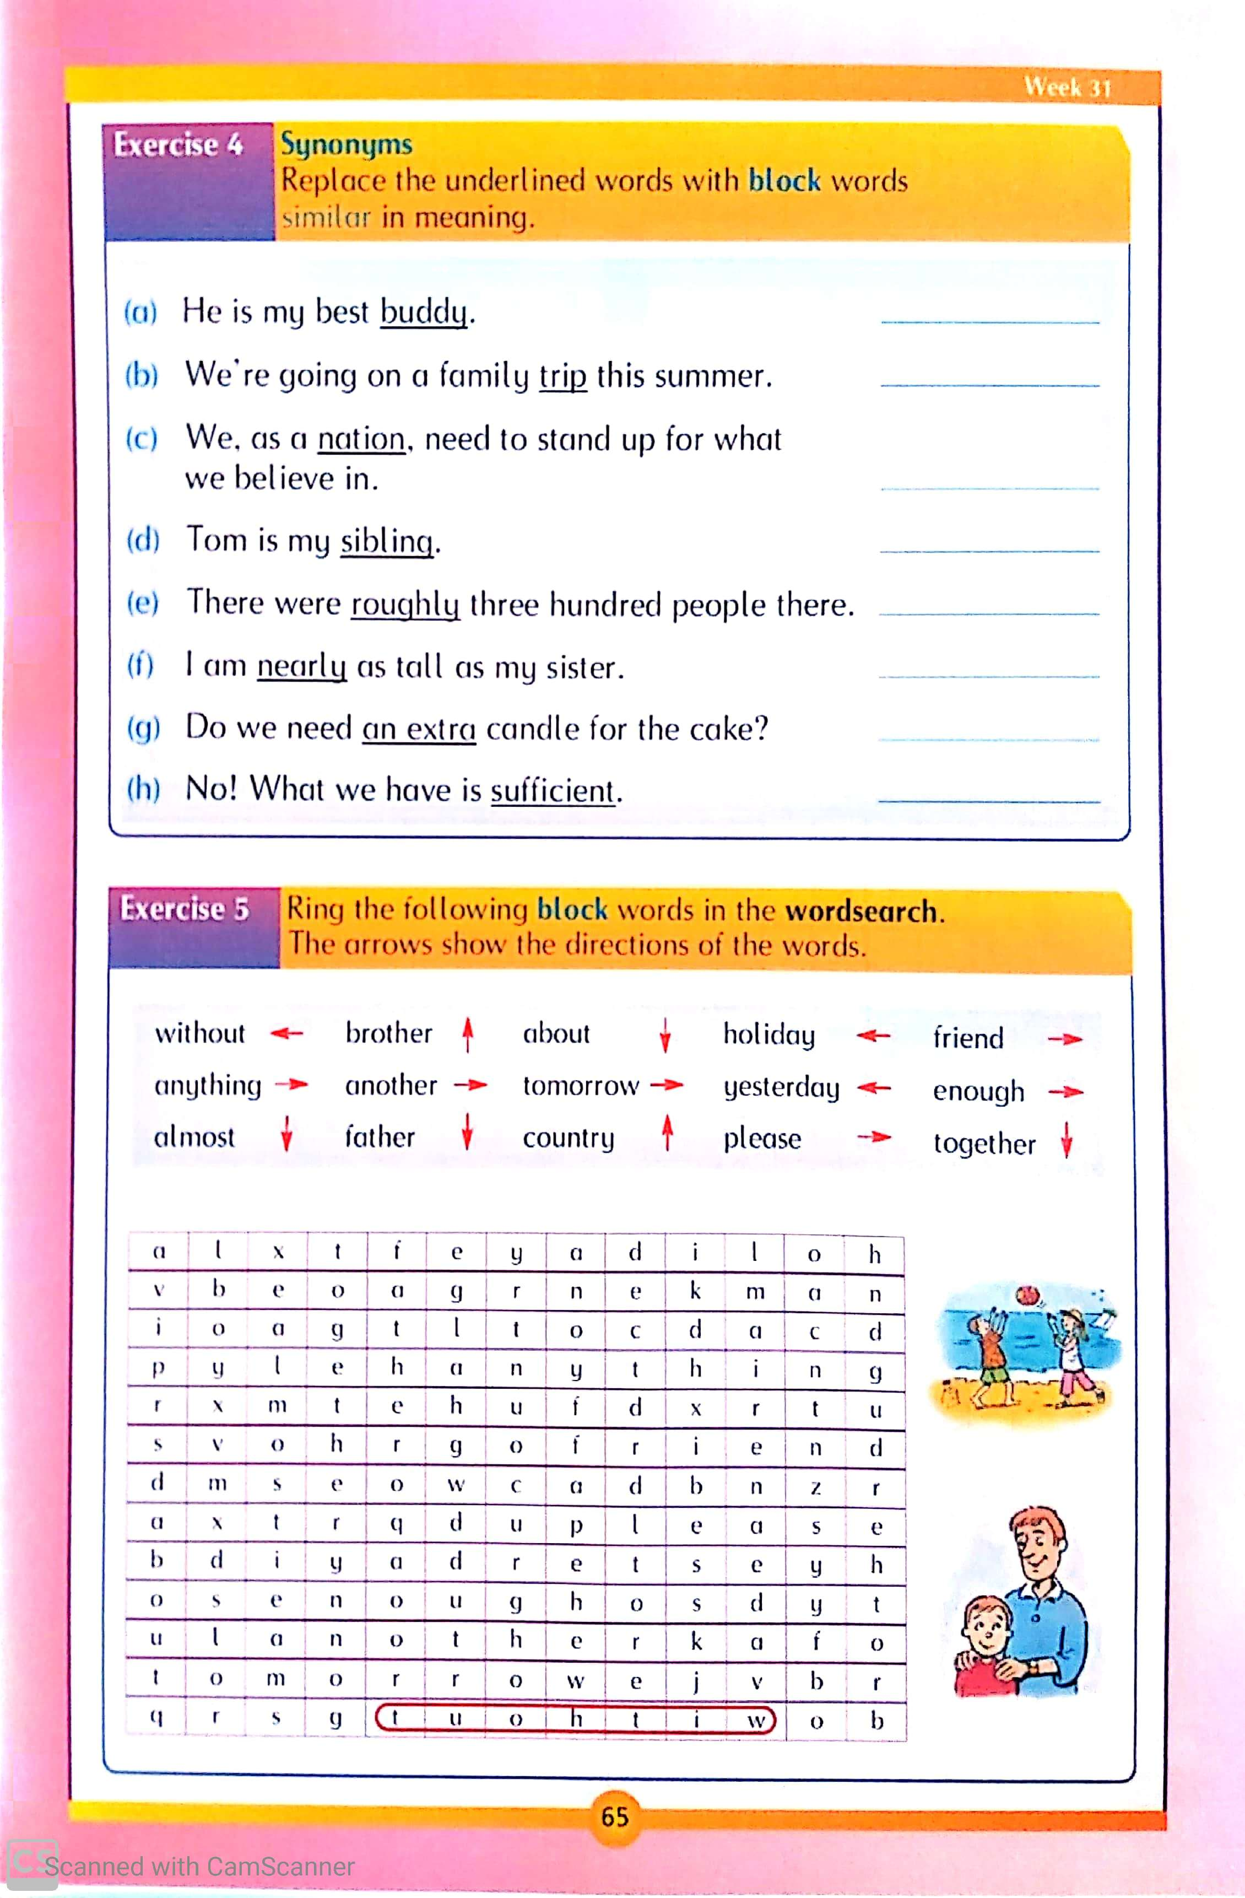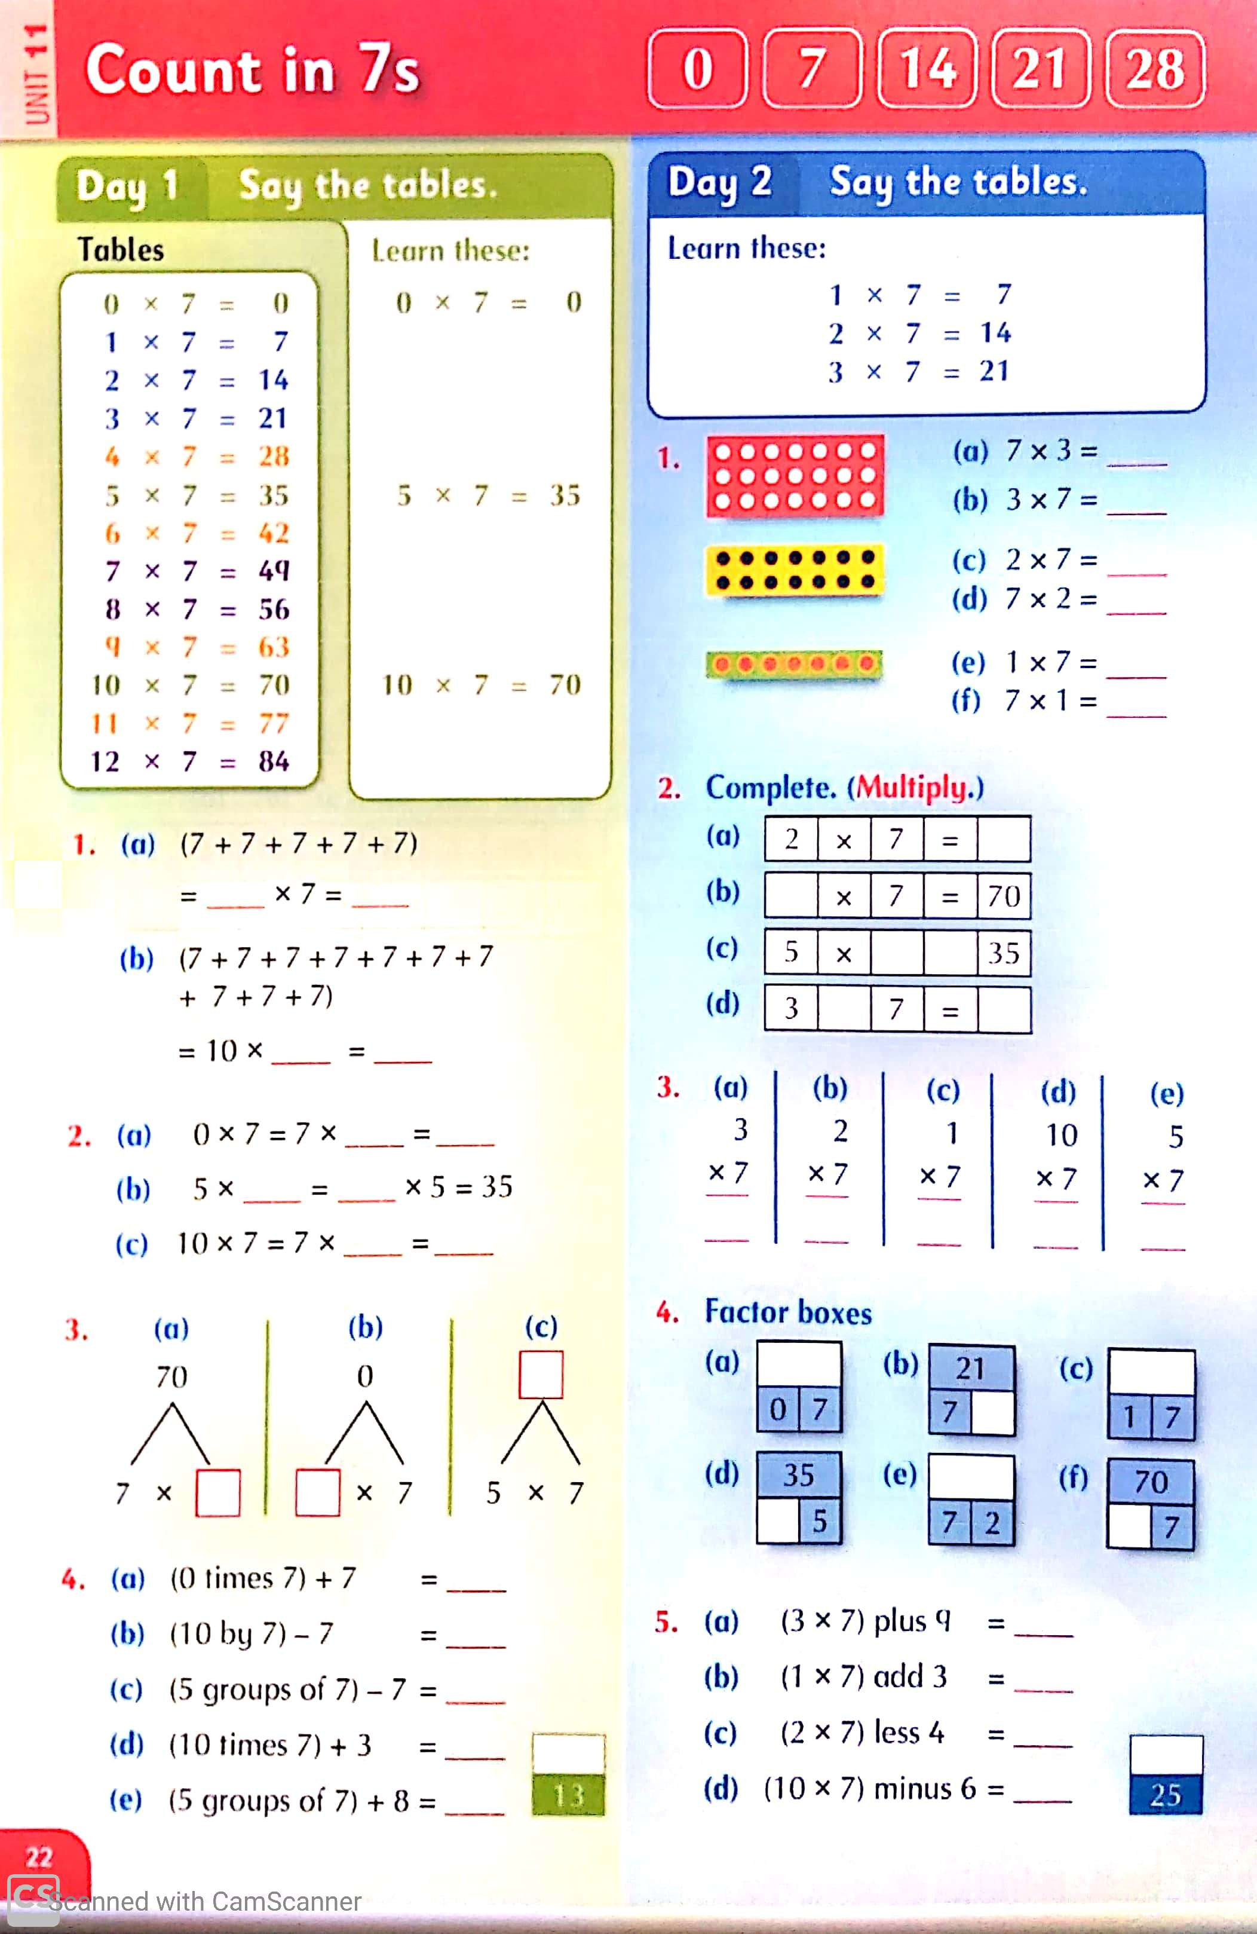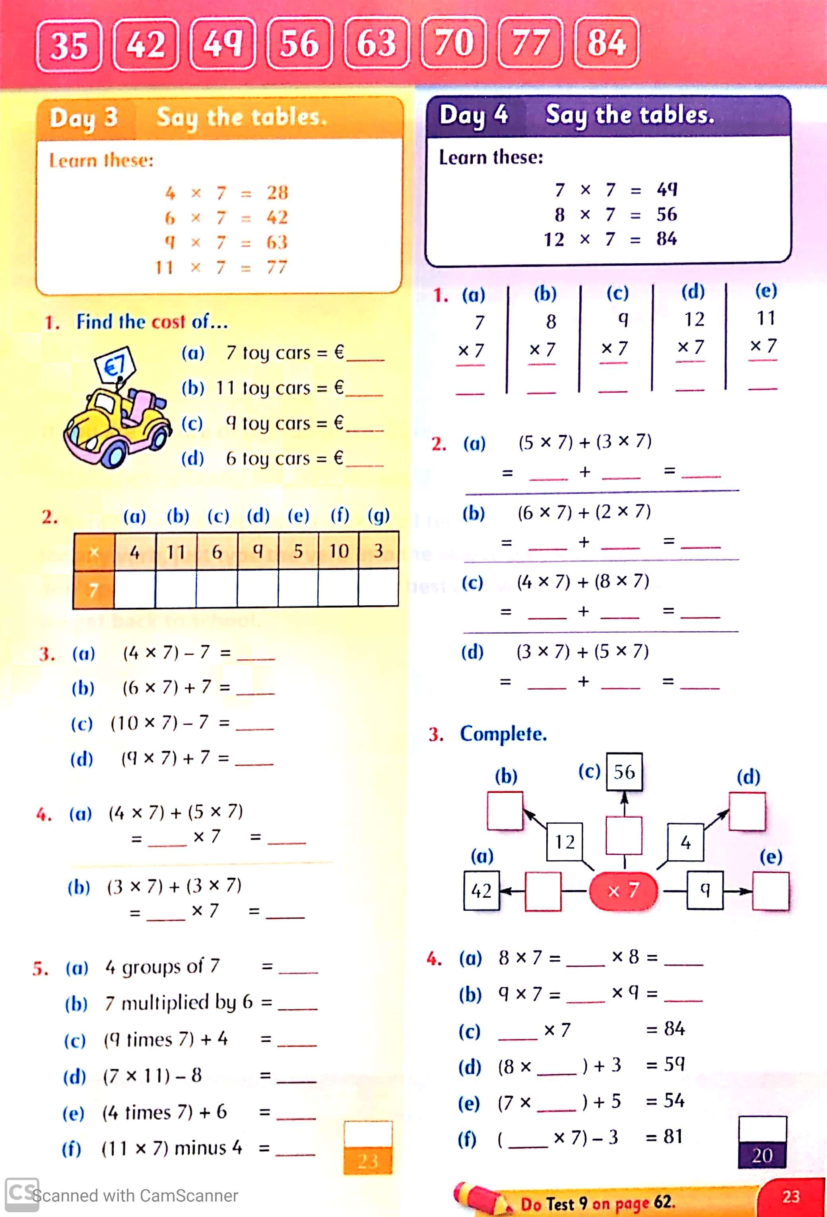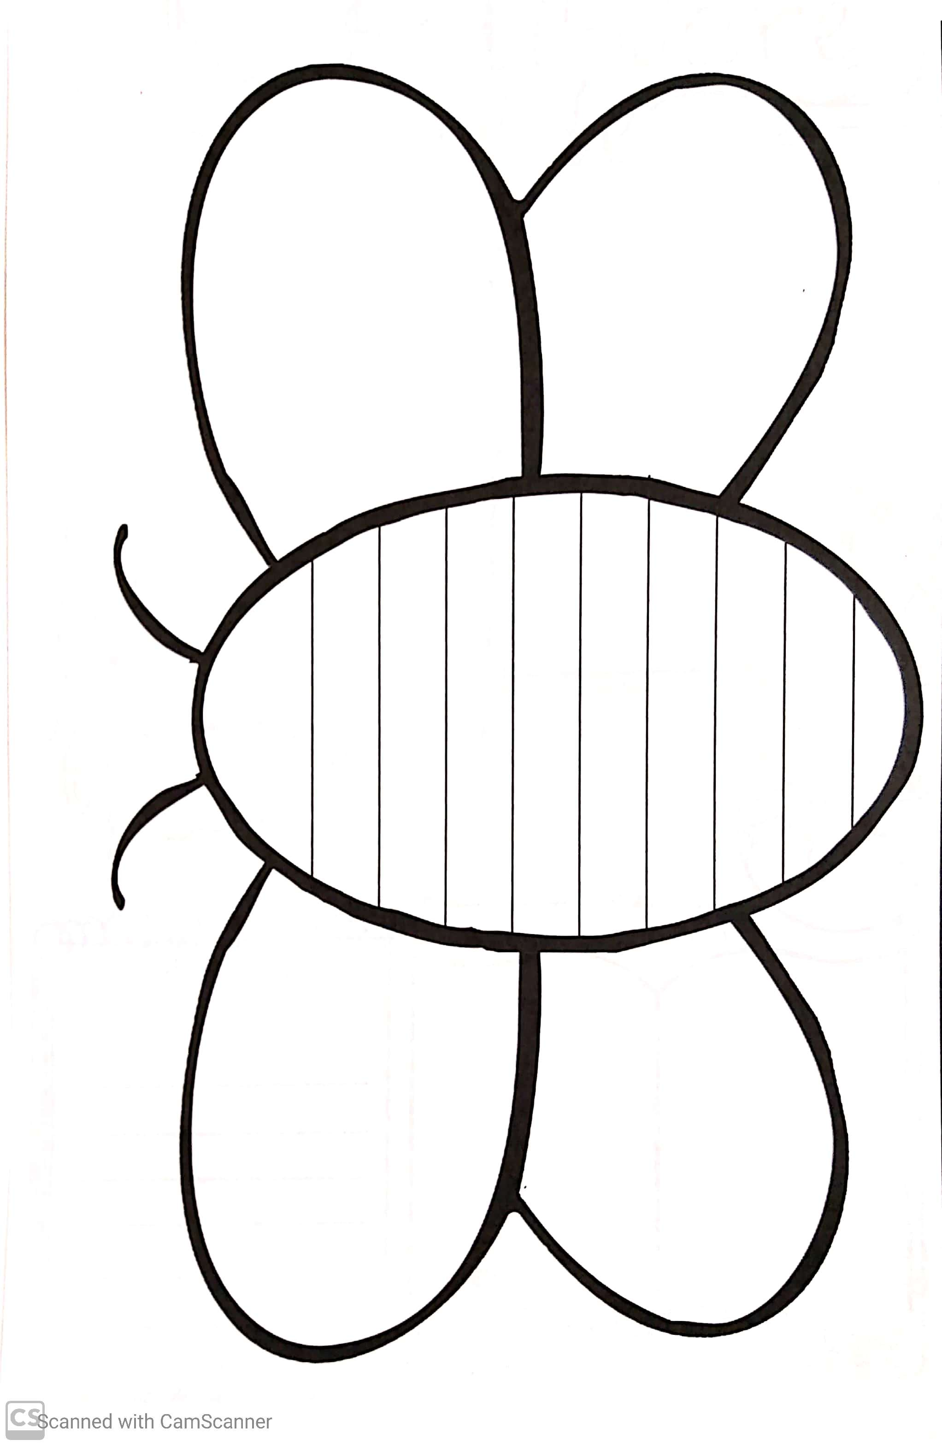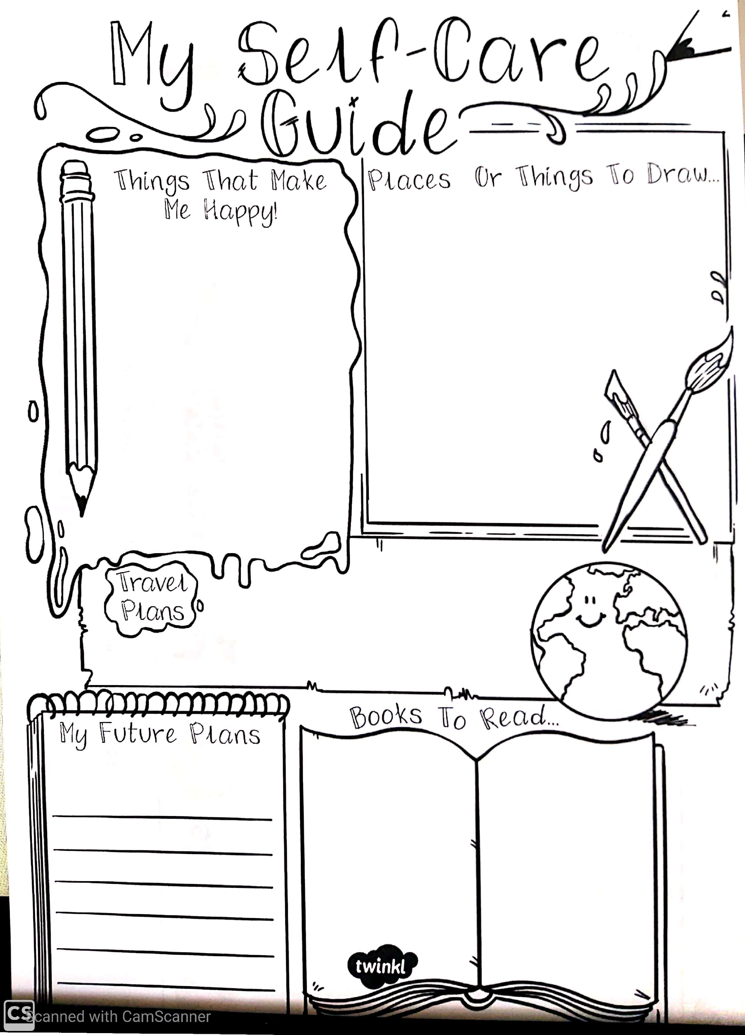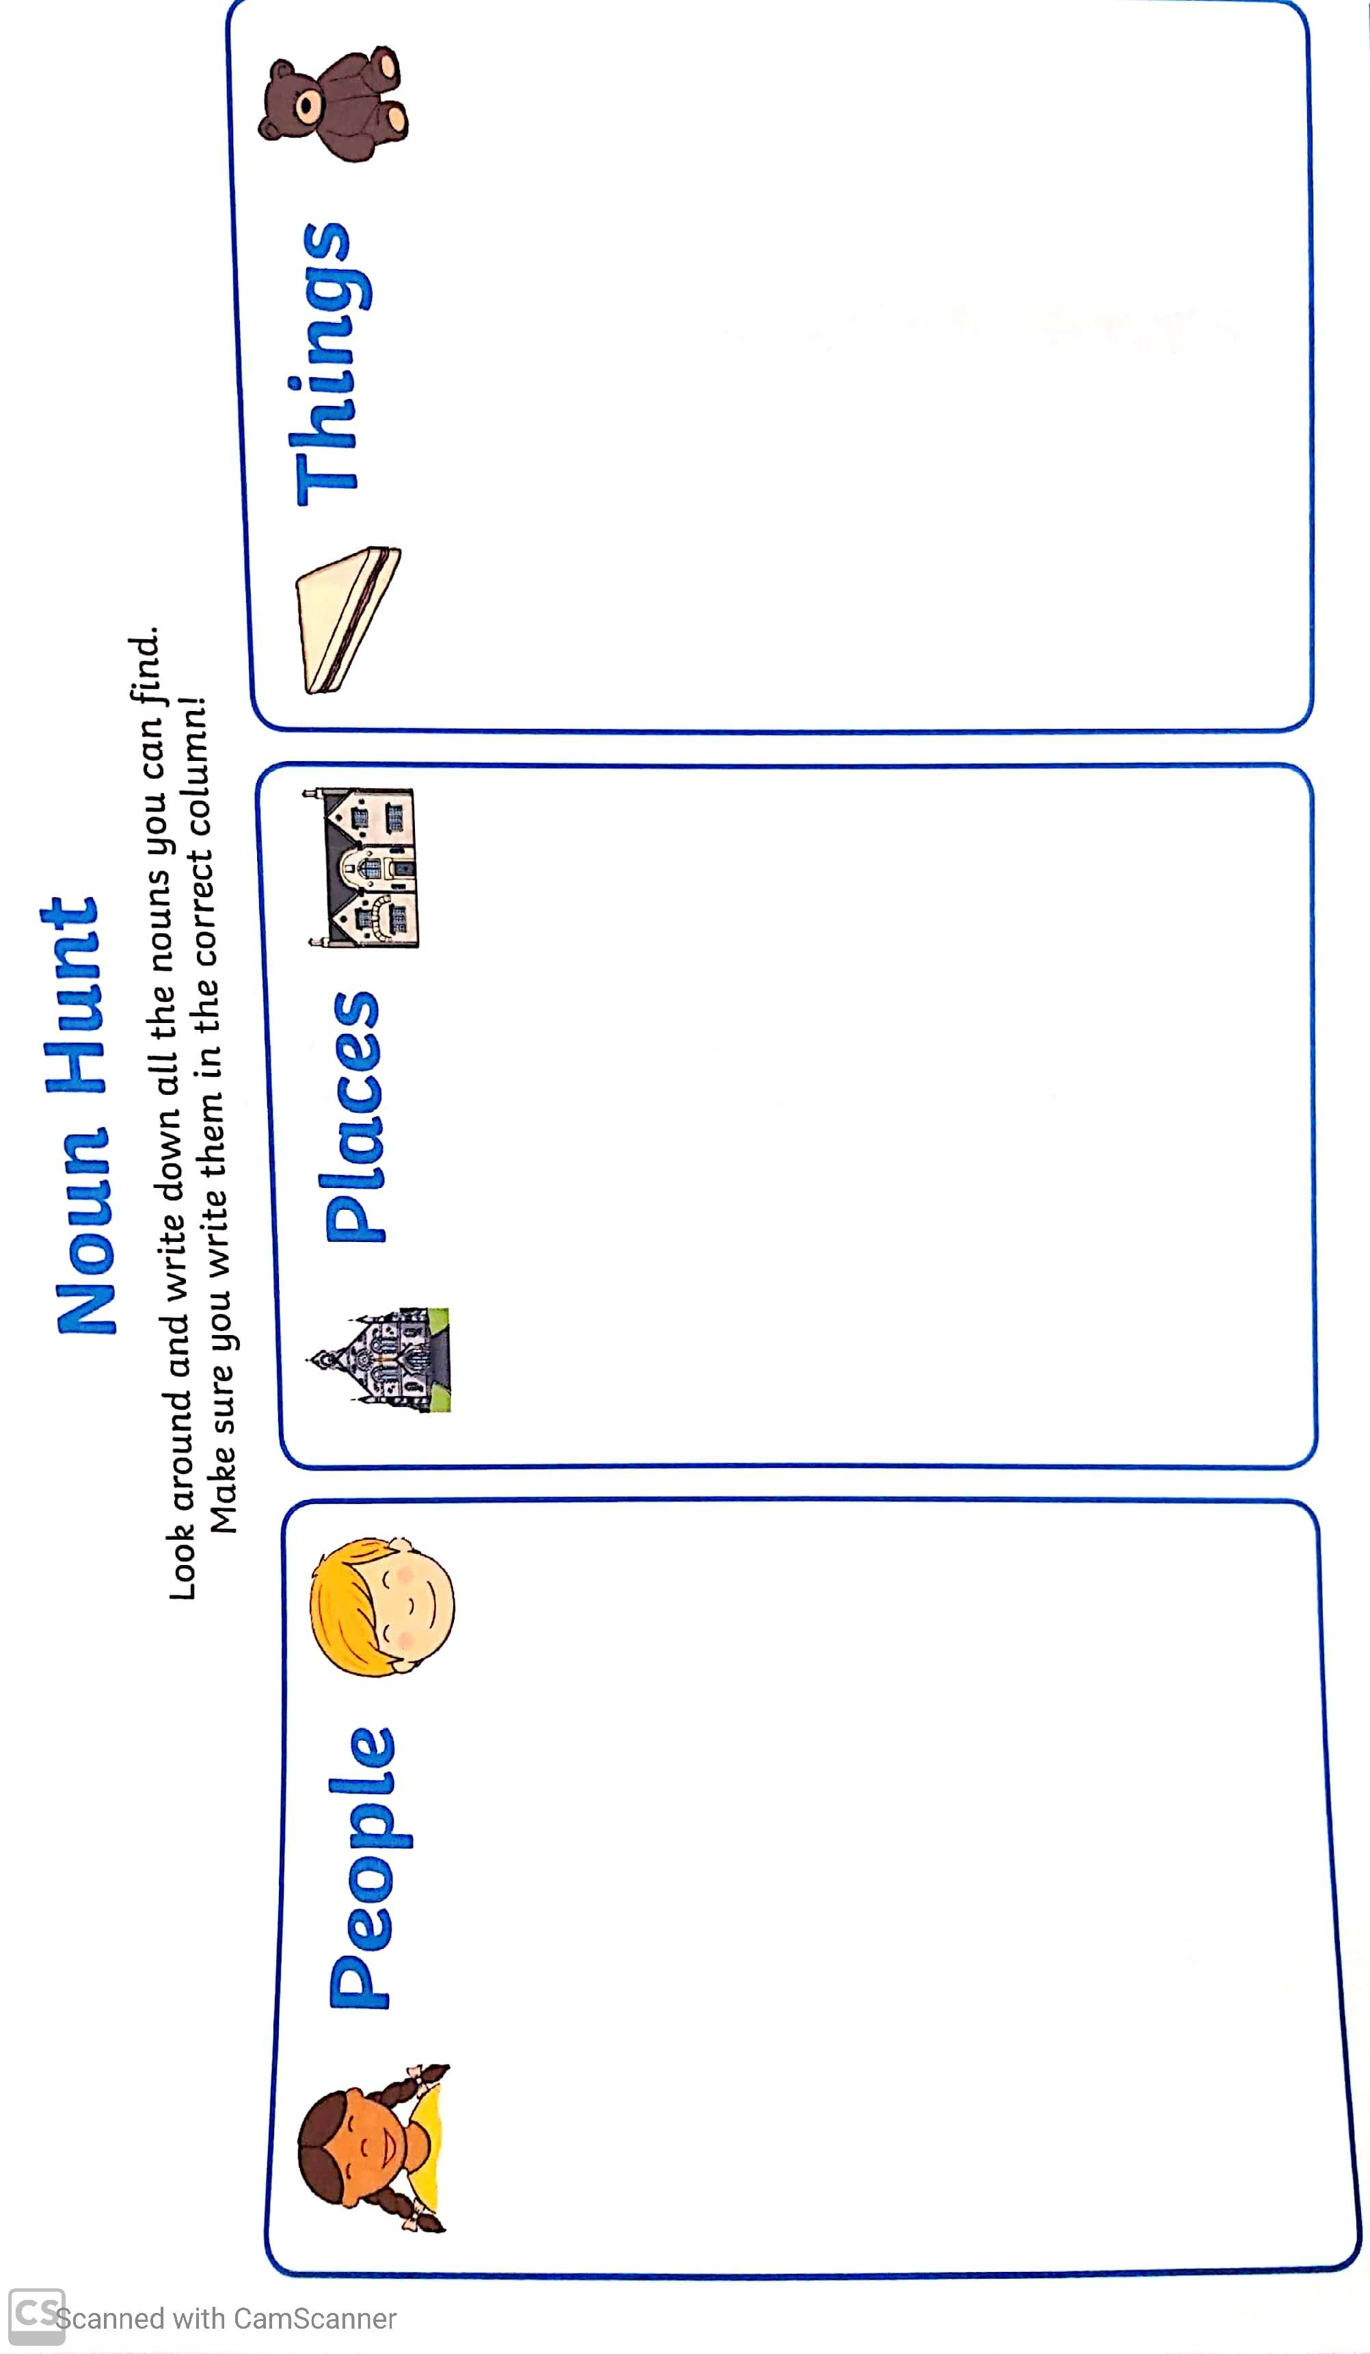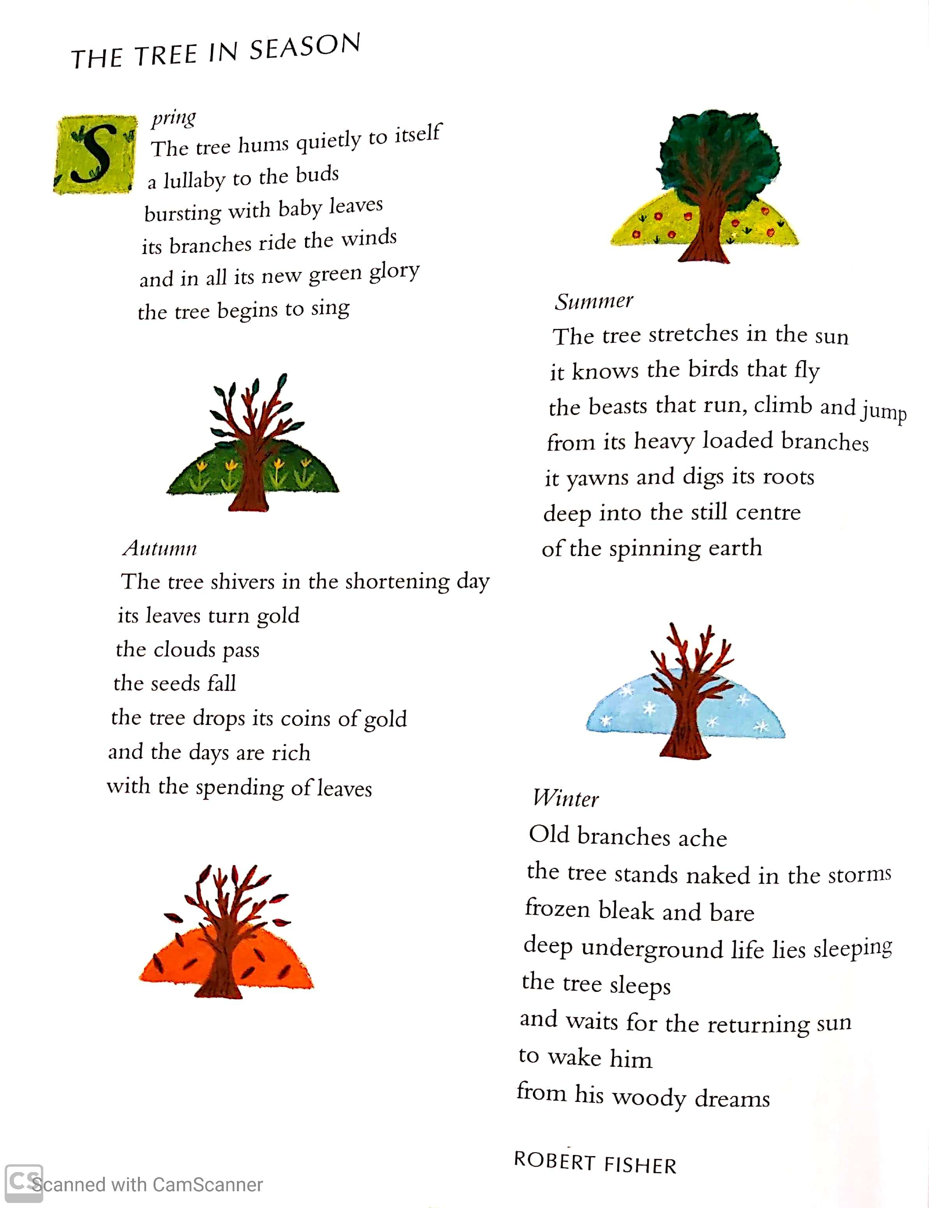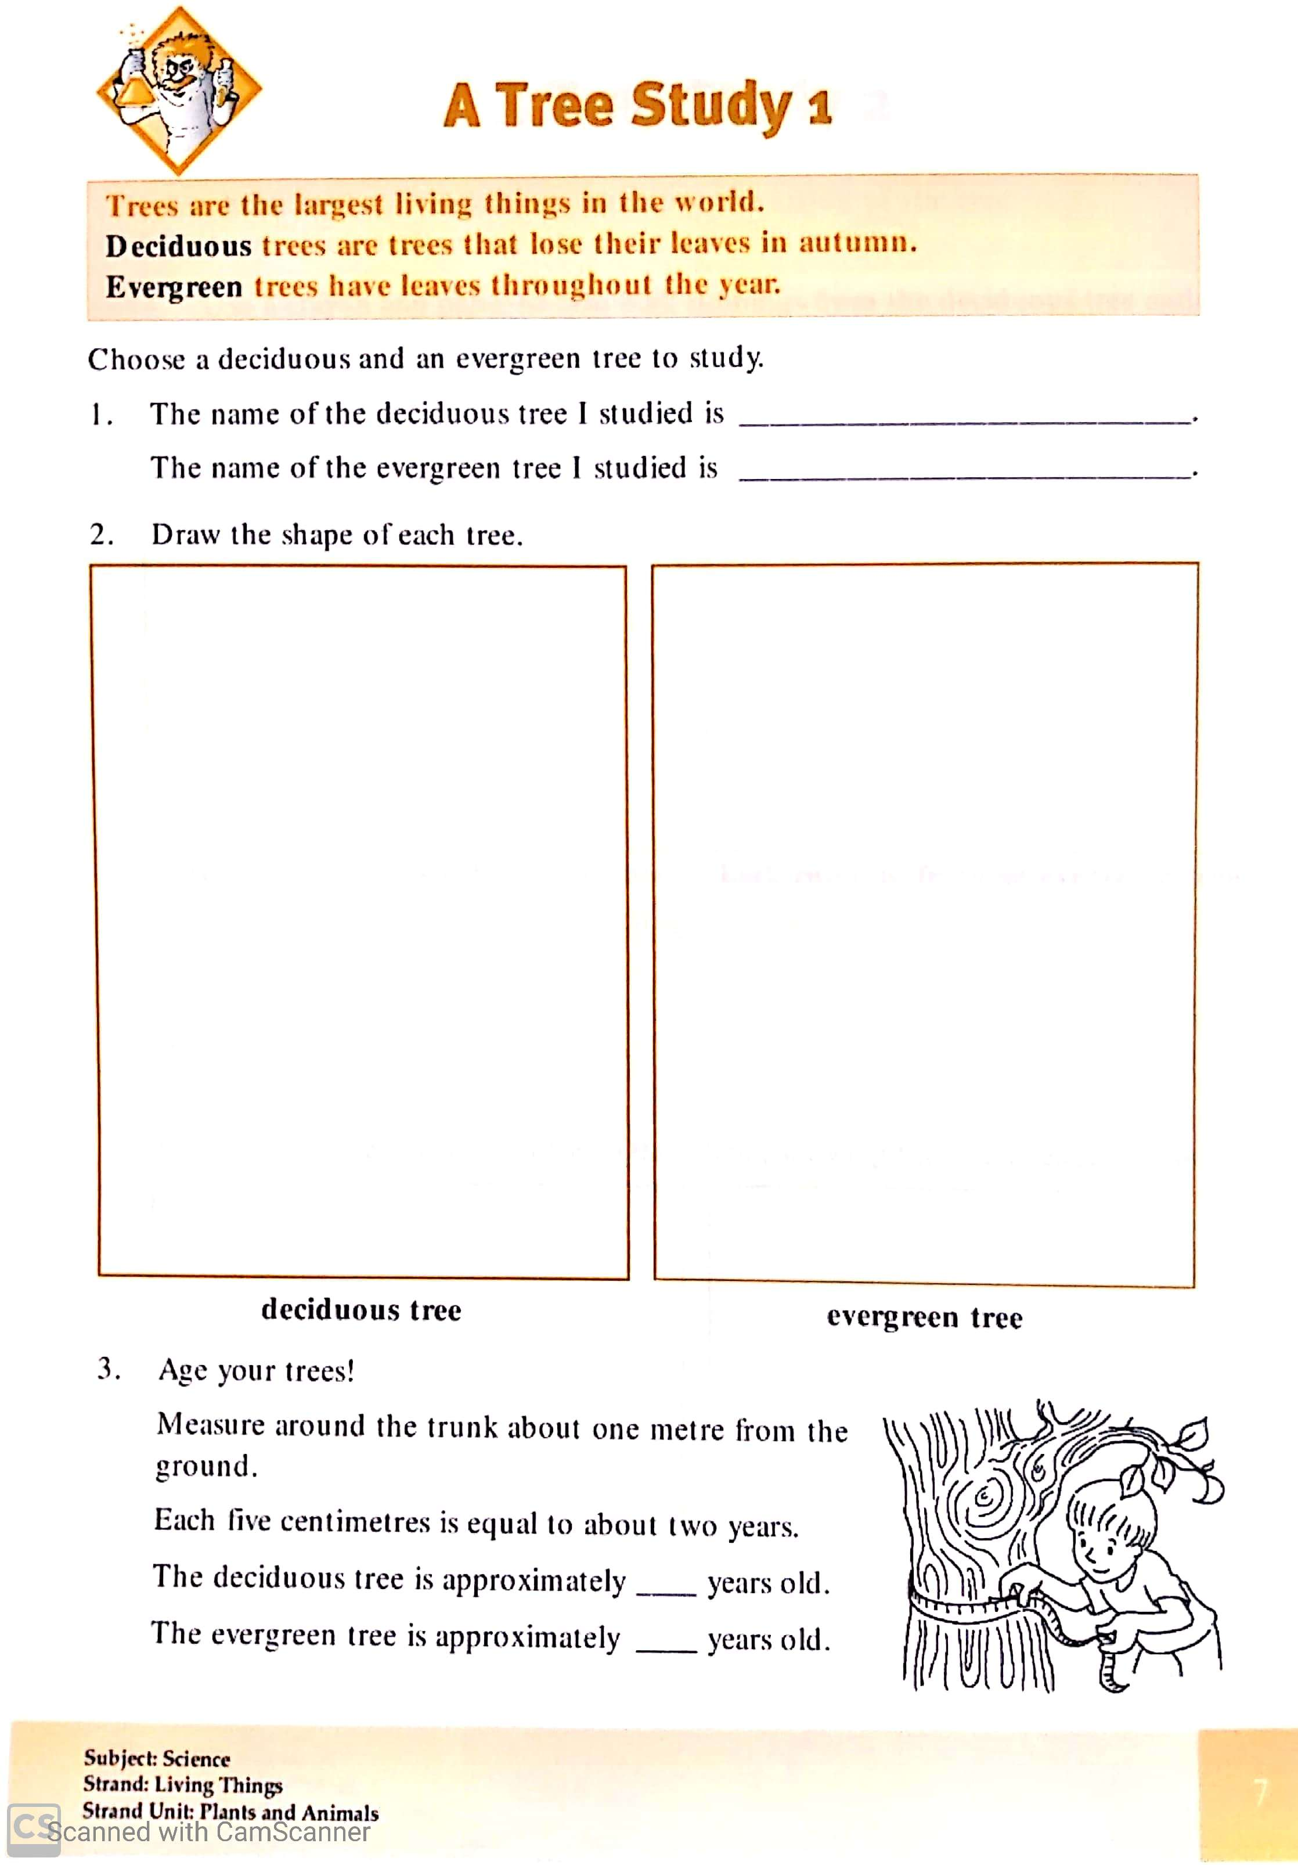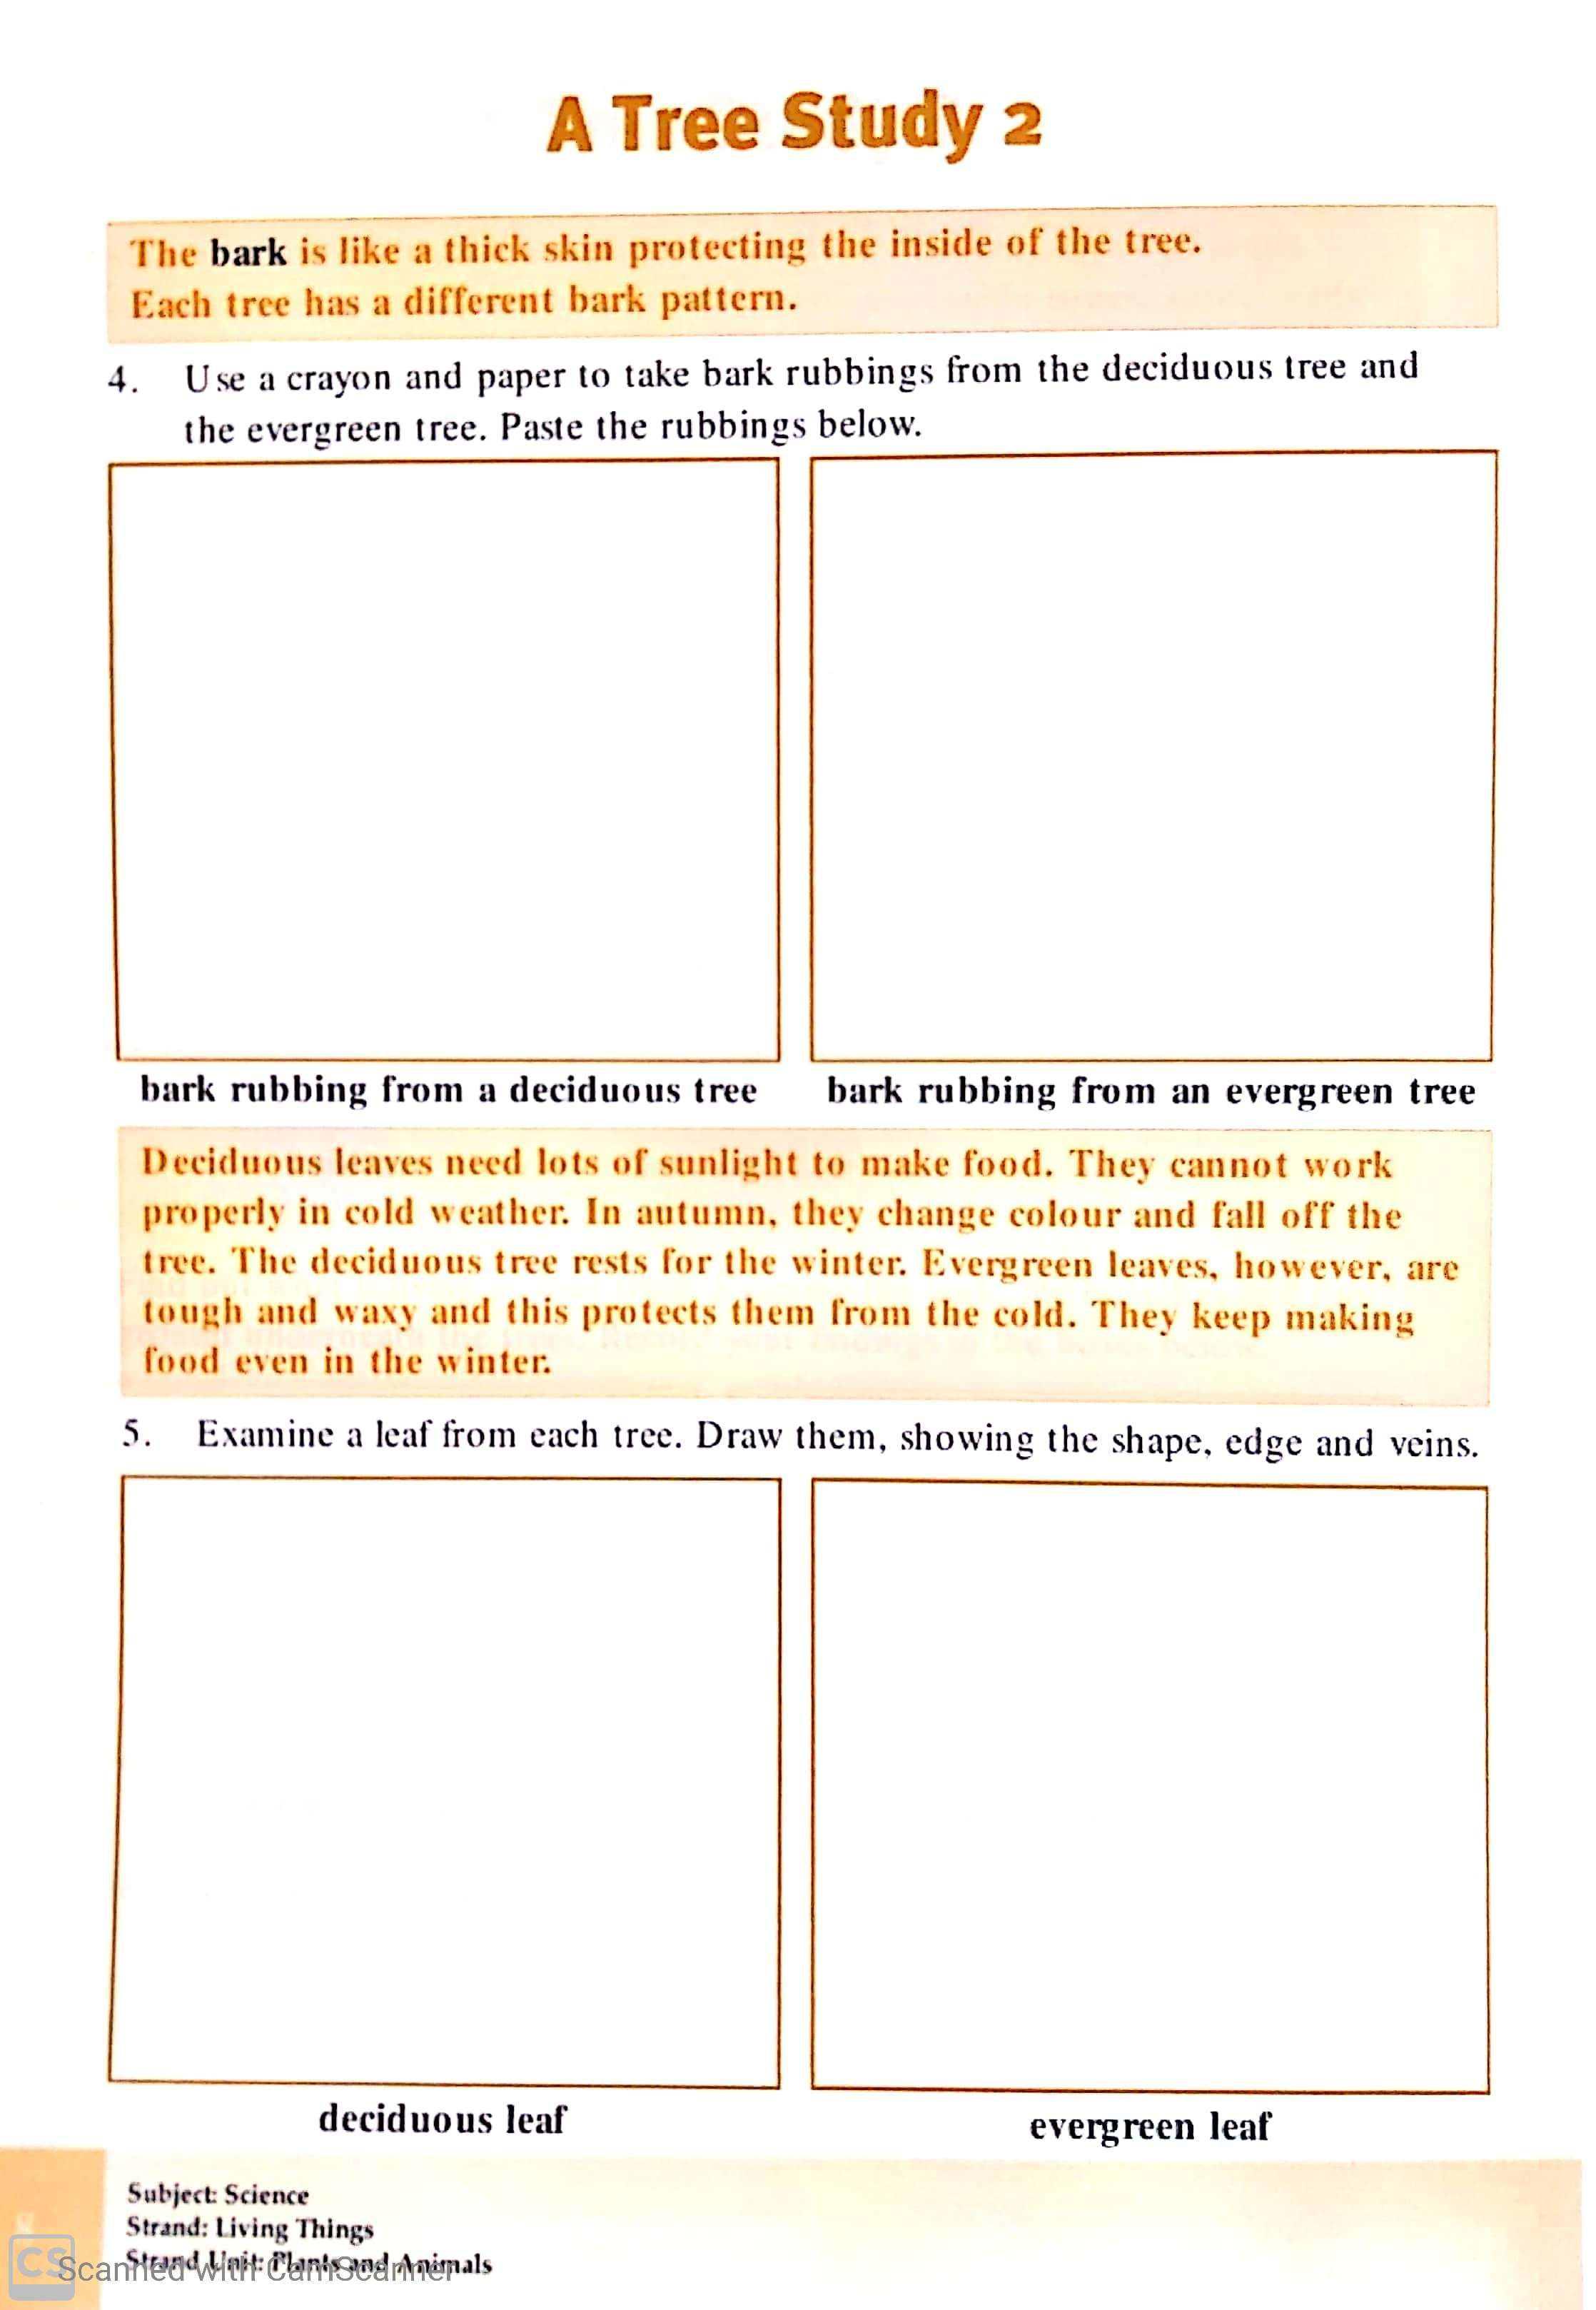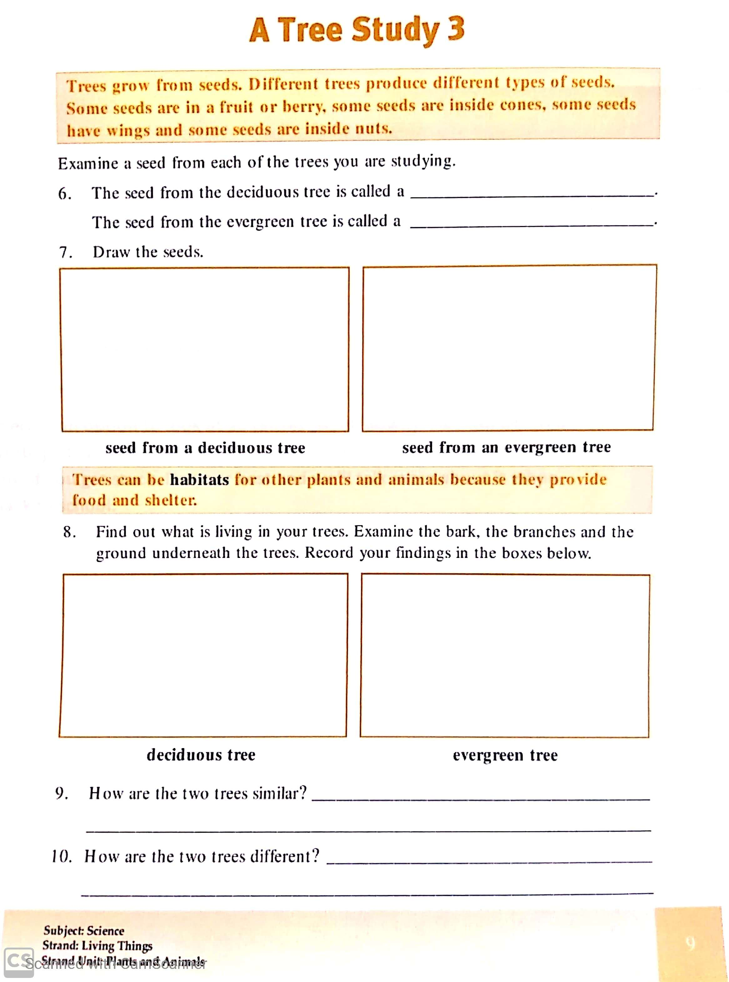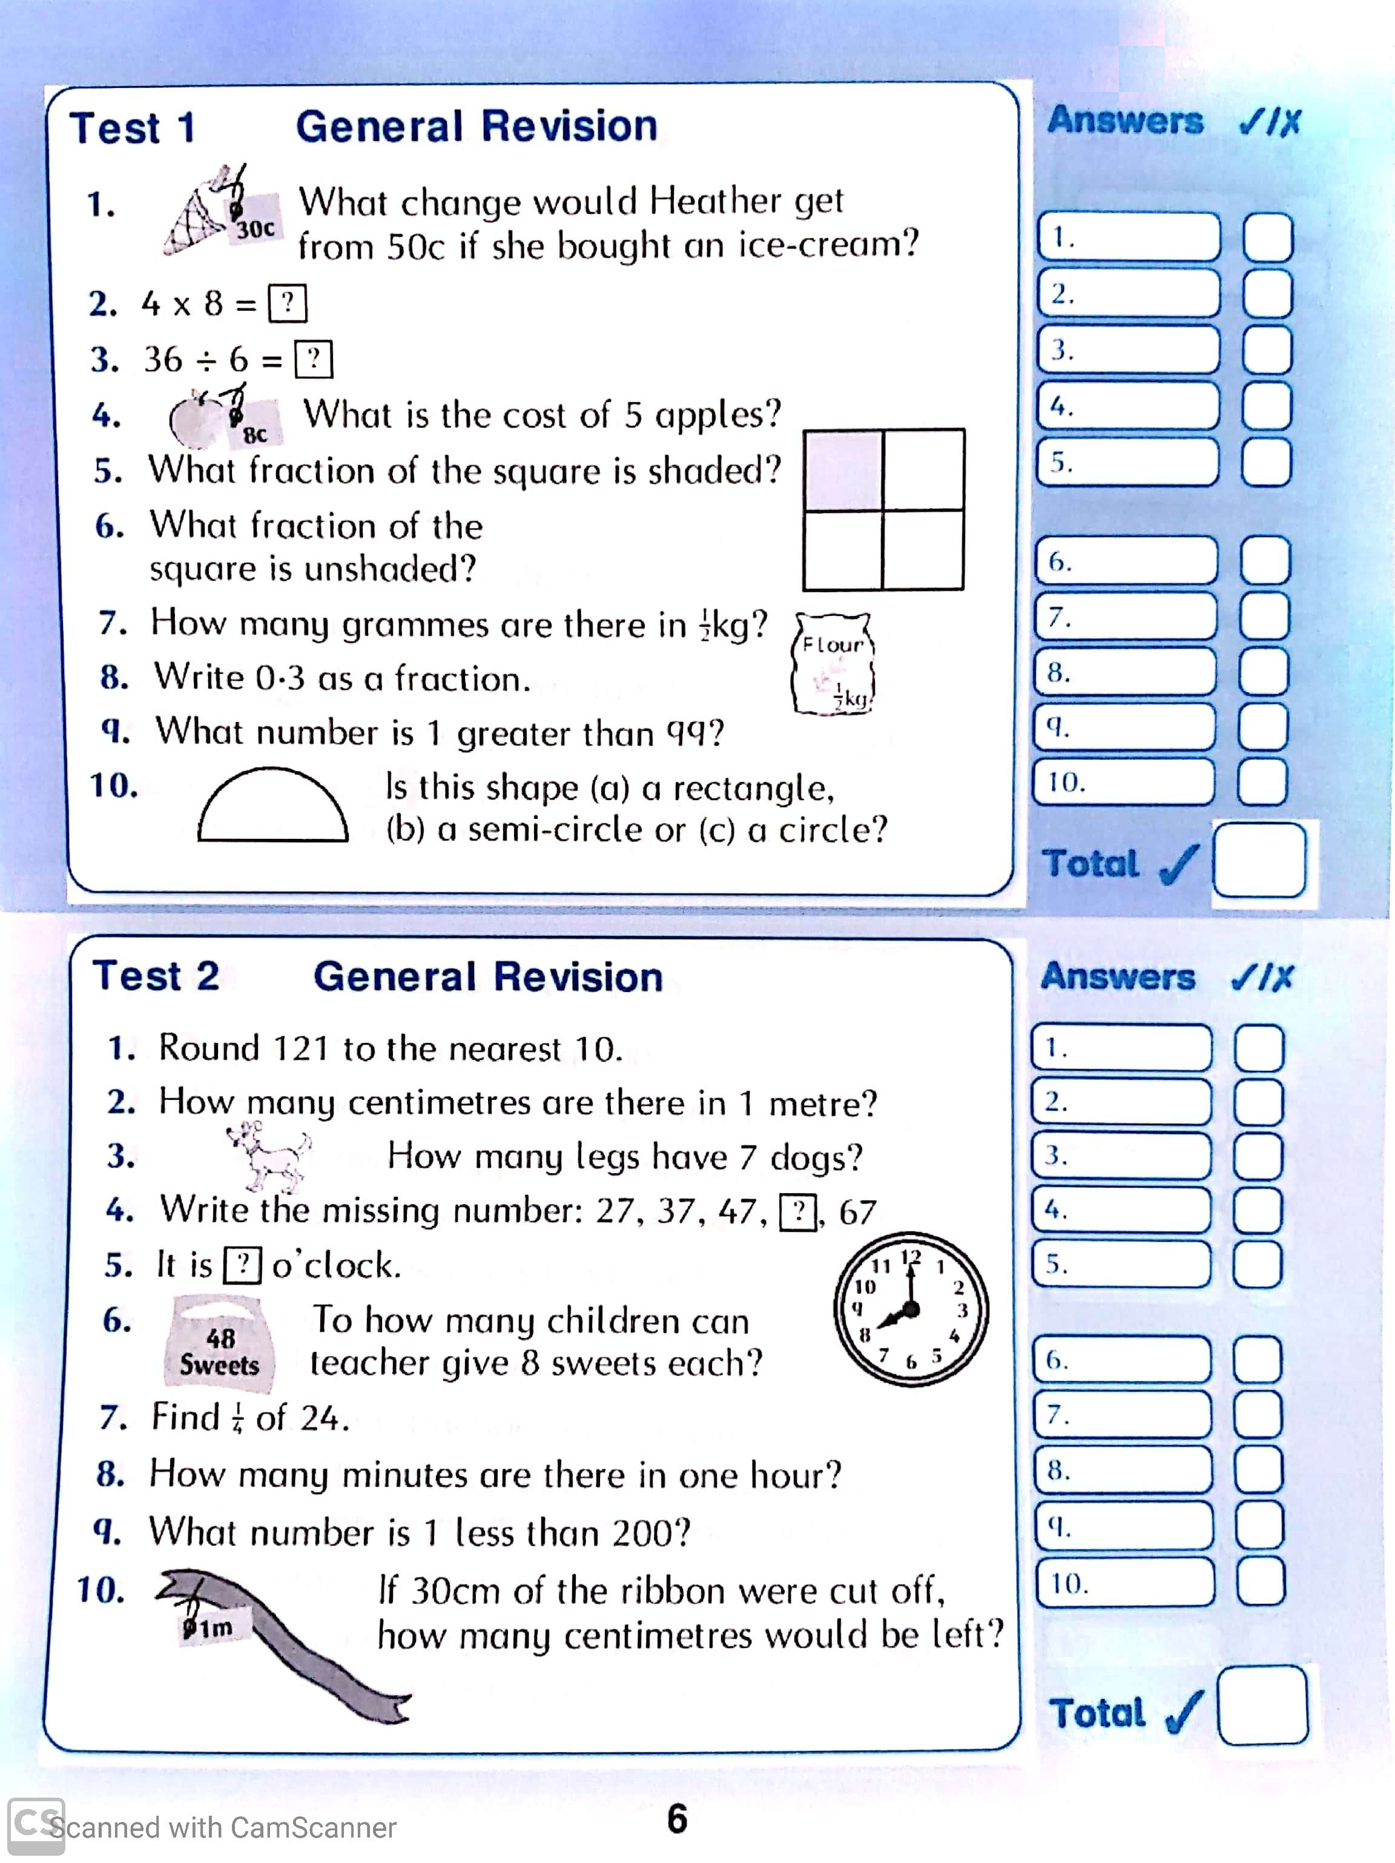

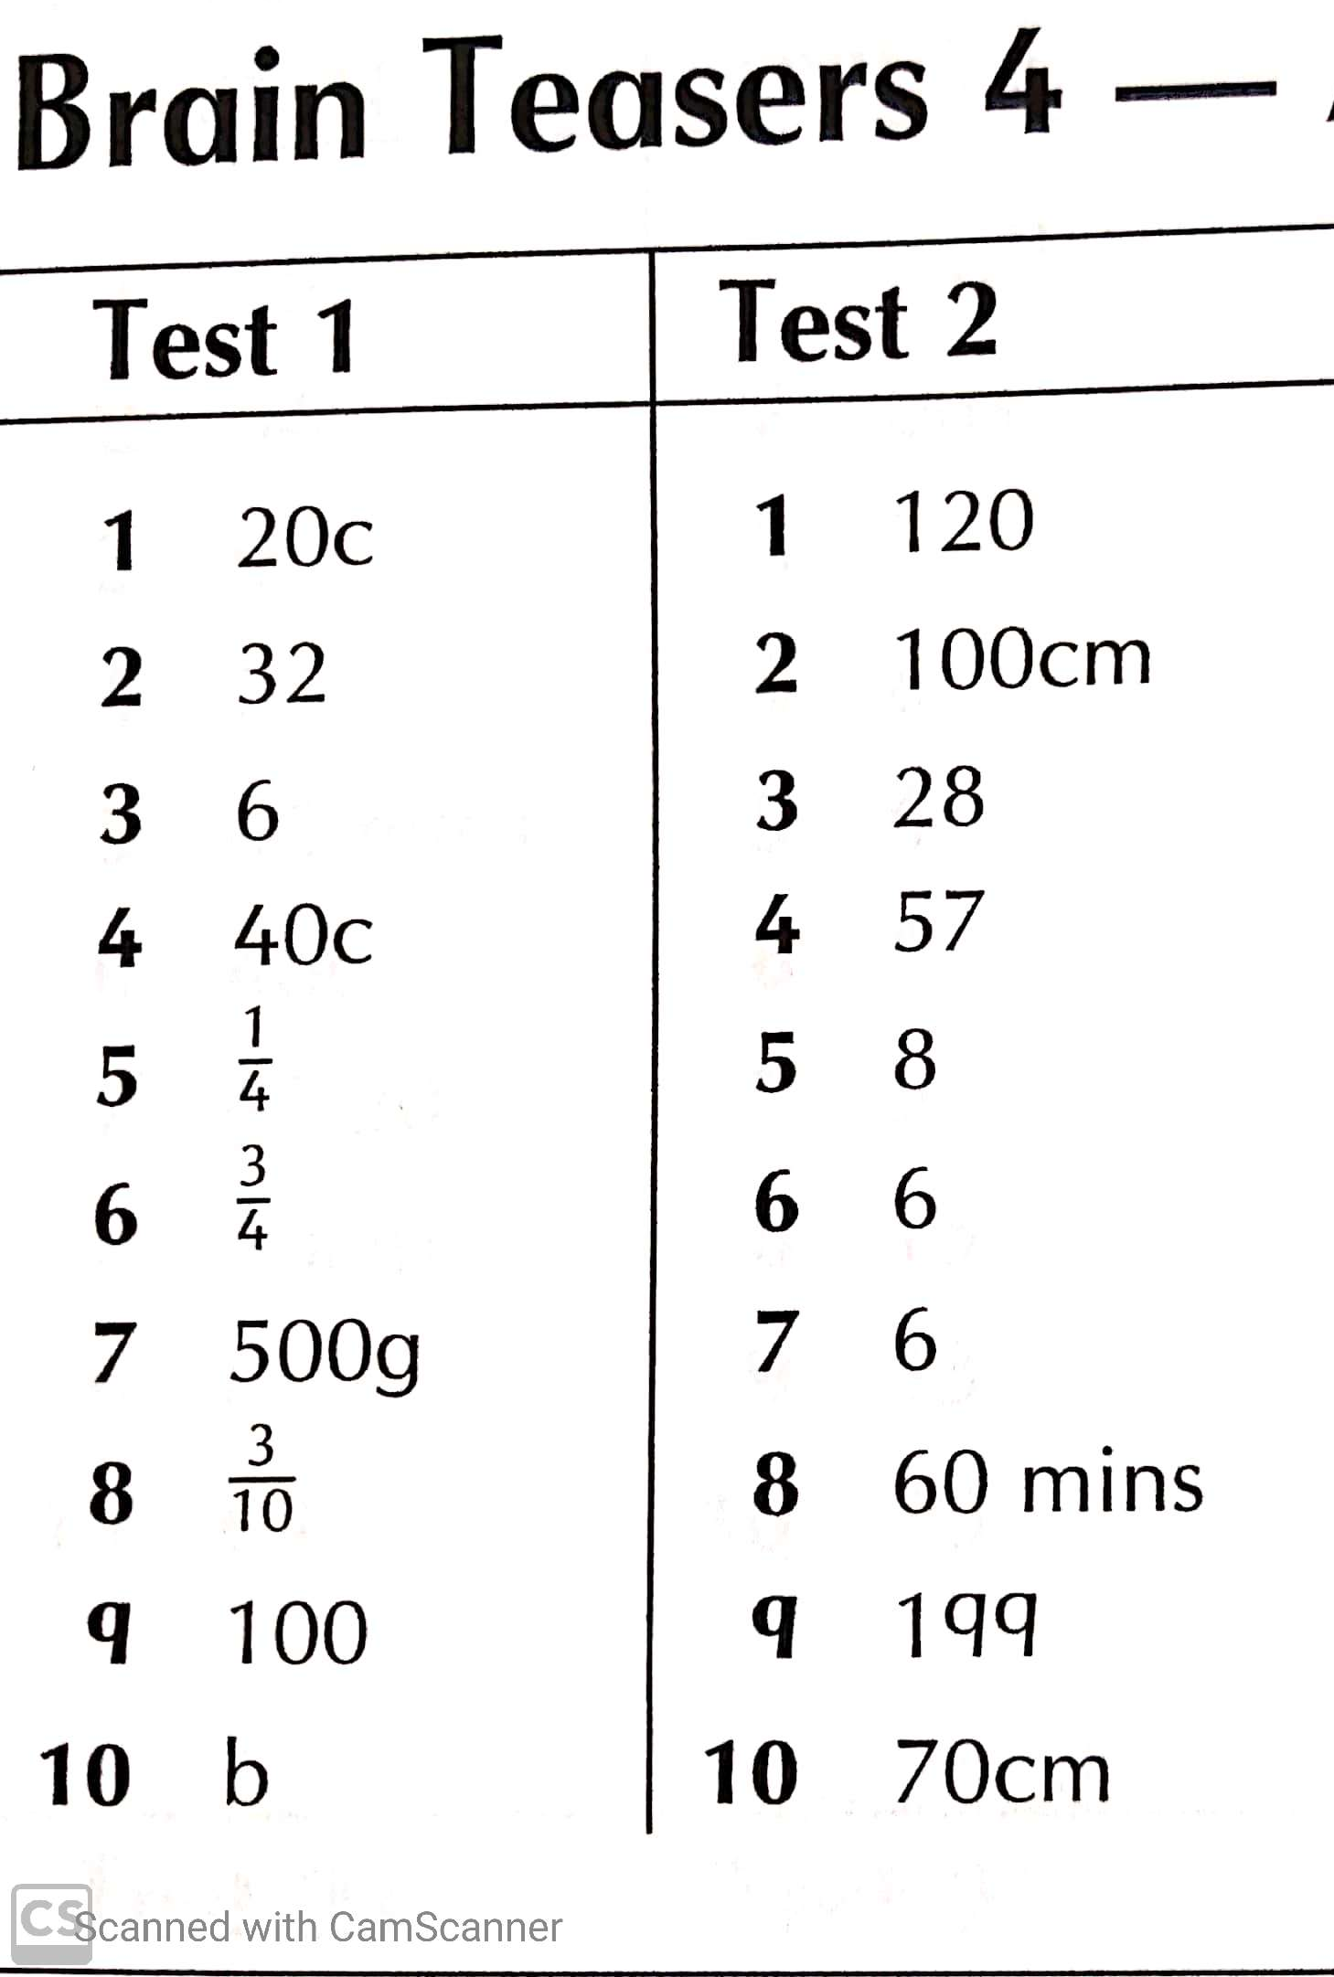

General Revision Test Answers
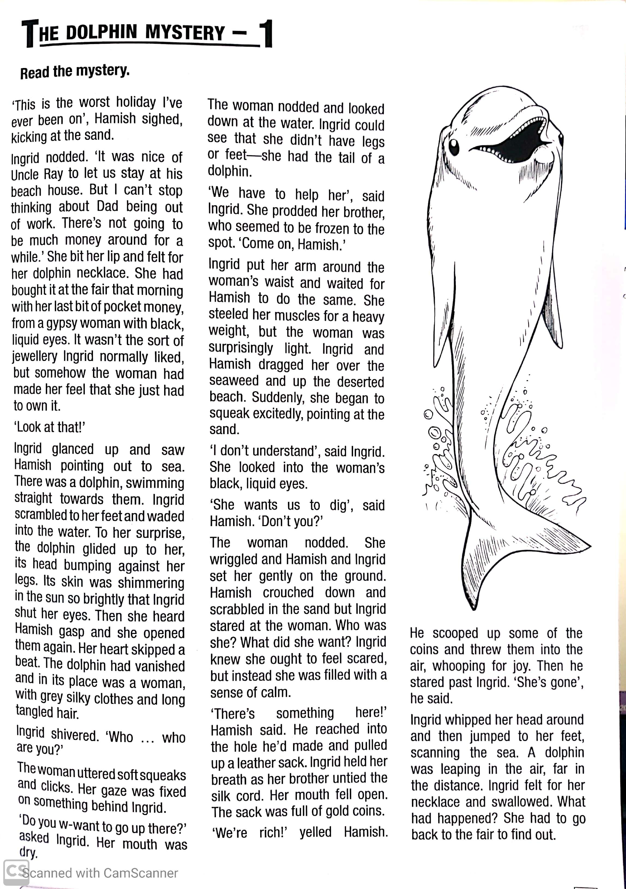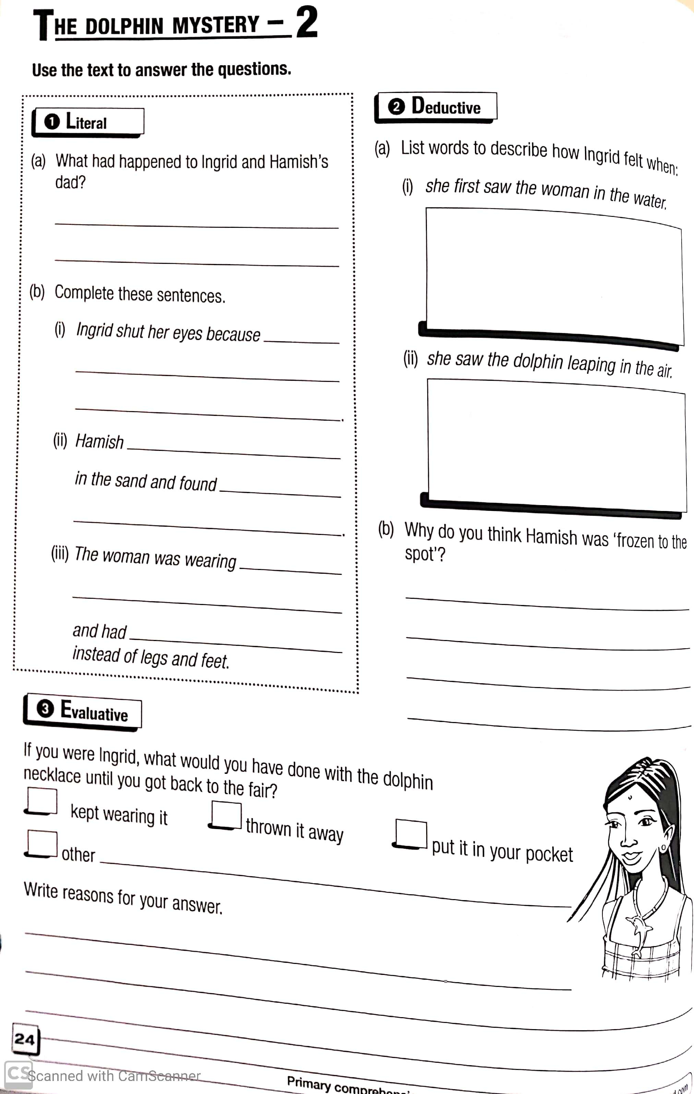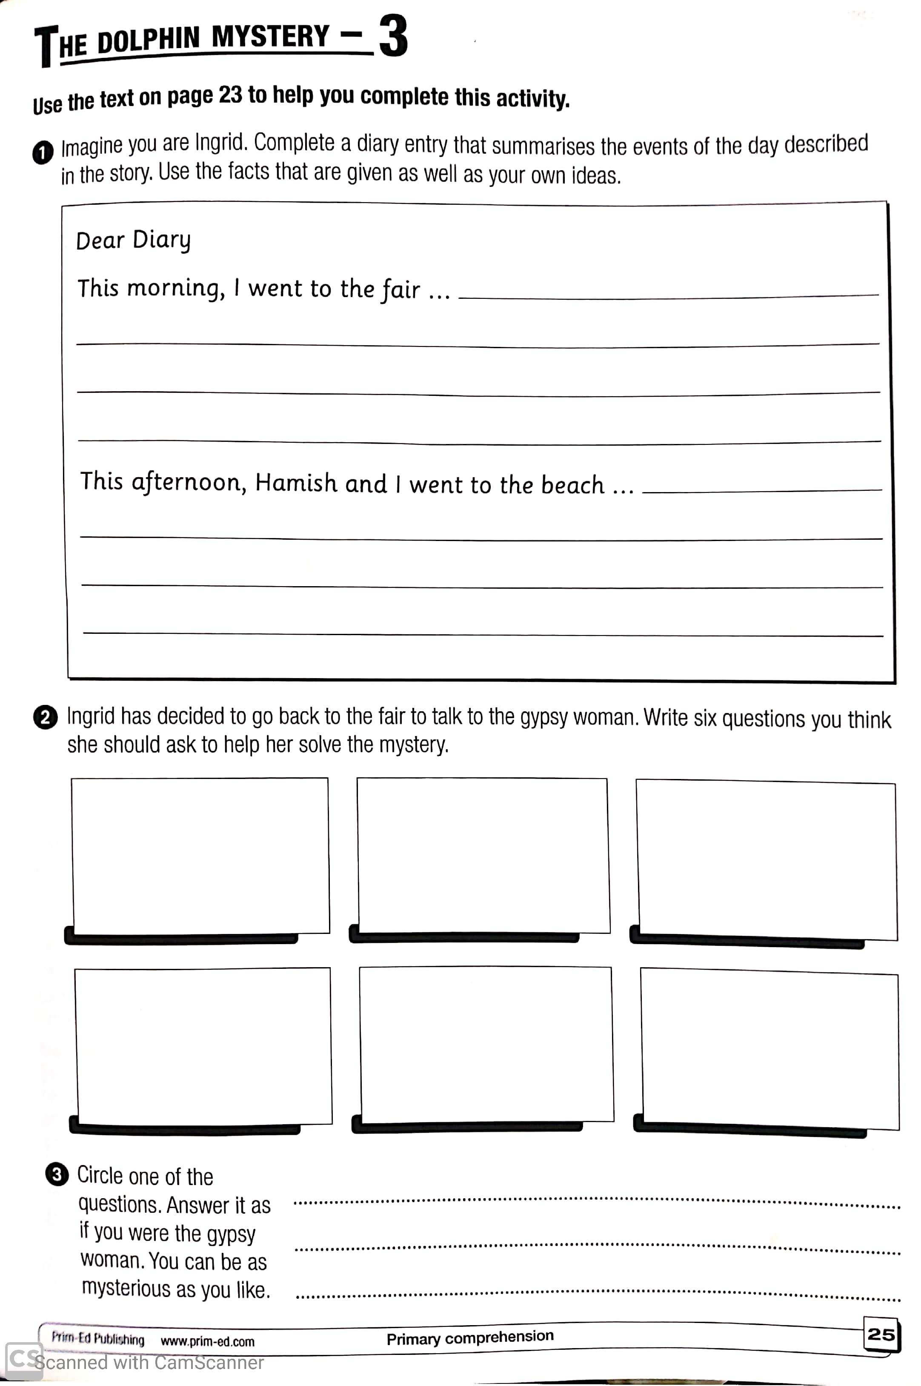
Week 31 Mental Maths Answers

Monday | Tuesday | Wednesday | Thursday | Friday | Problem Solving
Q1. 7.44 | Q1. 2.08 | Q1. 9.39 | Q1. 5.24 | Q1. 10.42 | Monday
Q2. 5cm | Q2. 2,000 | Q2 1 hour 30 mins | Q2. 30 | Q2. 30 | Q1. A and D  B and E  F and C
Q3. 2.5km | Q3. 9,000 | Q3. 1.2 | Q3. Triangular prism | Q3. 2.7 | Q2. Adult Check
Q4. 25 | Q4. 1.1 | Q4. 9,000 | Q4. 0.9 | Q4. 25
Q5. 30 | Q5. 3 | Q5. Cyclinder | Q5. 50cm | Q5. 7,000 | Tuesday
Q6. 1 | Q6. 30 | Q6. 25 | Q6. 100 | Q6. 1.3 | Q1. A regular pentagon has no parallel lines
Q7. 4/6 = 6/9 | Q7. 2 | Q7. 30 | Q7. ½ L | Q7. 11cm | Q2. 5
Q8. 1.0 | Q8. ¼ L | Q8. Adult check | Q8. 25 | Q8. 9,000
Q9. Cuboid | Q9. 72/100 | Q9. 5 | Q9. 3,800 | Q9. 11 | Wednesday
Q10. 1,400 | Q10. Adult check | Q10. 4 | Q10. 200 | Q10. 3.4 km | Q1. B
Q11. €4 | Q11. 7.99 | Q11. 15 minutes | Q11. 4 | Q11. Yes | Q2. B
Q12. 3 | Q12. 5.6 | Q12. 390 | Q12. 8,000 | Q12. 1 hour 15 mins
Q13 yes | Q13. Octagon | Q13. 1.3 | Q13. 0.7 | Q13. 7.78 | Thursday
Q14. 150 | Q14. 8 minutes | Q14. 2.48 | Q14. Vertical | Q14. 3.0 | Q1. €500
Q15. 2 hours 15 mins | Q15. 190 | Q15. 5 | Q15. 50 | Q15. A | Q2. Obtuse
Q16. 820 | Q16. 24 | Q16. 3 in 9 | Q16. 4.25km | Q16. Adult check
Q17. 24 | Q17. 5.2km | Q17. 5 in 9 | Q17. 3 | Q17. ¾ L
Q18. 9 | Q18. Yes | Q18. Blue | Q18. Adult check | Q18. 6/9
Q19. 7/10 | Q19. €2 | Q19. Red | Q19 490 | Q19. 15 mins
Q20. False | Q20. 300 | Q20. yellow | Q20. Adult check | Q20 490
 |  |  |  | Q21. Adult check
 |  |  |  | Q22. €1
 |  |  |  | Q23. 760
 |  |  |  | Q24. 480
 |  |  |  | Q25. 32m

