Final Weeks Work: 22nd June to 26th June 2020

Hello boys. It is the final week of the school year and to say the least it has been the most unusual year. I want to firstly congratulate each and every one of you on your interaction both when in school but also since March when asked to continue your studies from home. This year is definitely one we will not forget in a hurry. For our final week the activities are just going to be purely for fun. There will be a wide variety of activities suggested to you for your enjoyment! As always you are more than welcome to complete your own and potentially even more interesting material. Lastly I would just like to say I have thoroughly enjoyed having each and every one of you in my class this year and I wish you all the best in your holidays. I look forward to seeing you all back in Donacarney in September.
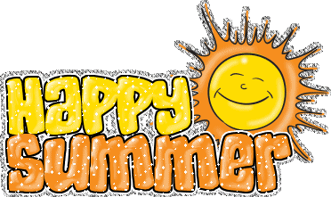

Activity One:
Movie Synonyms
You need to guess the movie from the clue. I will give you a couple examples. You may ask your parents to help you with these. It should be good fun!
Synonym | Movie
Colossal | Titanic
The Wildcard Monarch | The Lion King
Martial Arts Child
Speedy and enraged
The Ravenousness Matches
Iced
Unkind women
Abolisher
Courageous
Infant Motorist.
Assignment unimaginable

Activity 2: Guess the celebrity from baby picture:
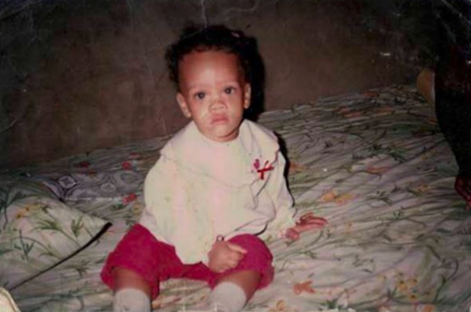
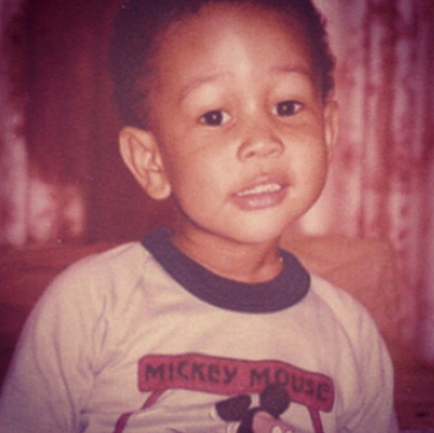
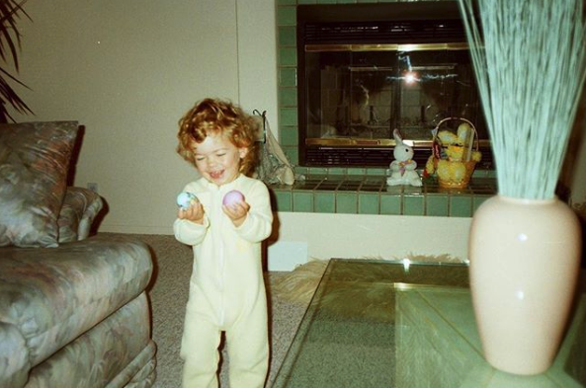
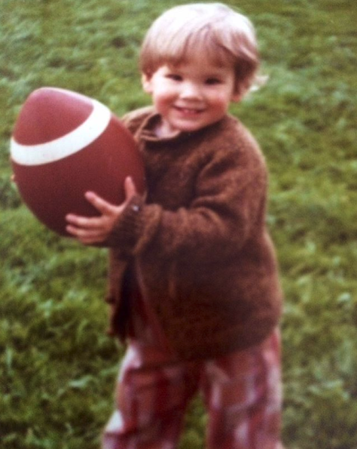
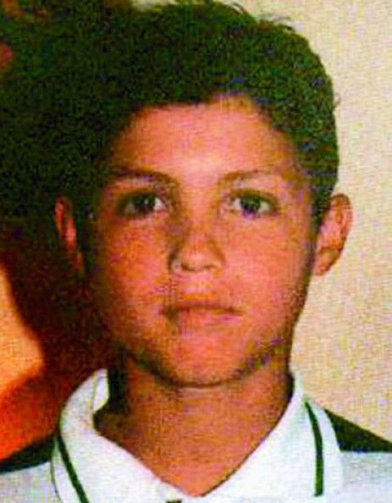
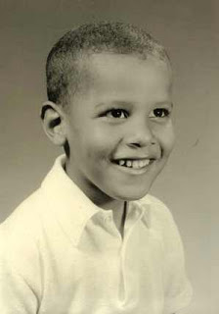
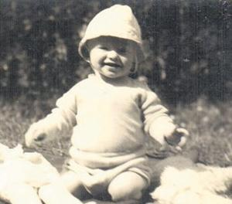

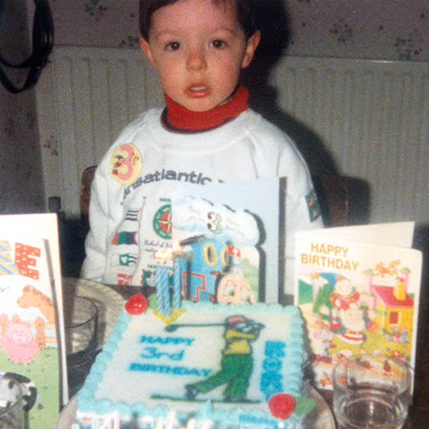
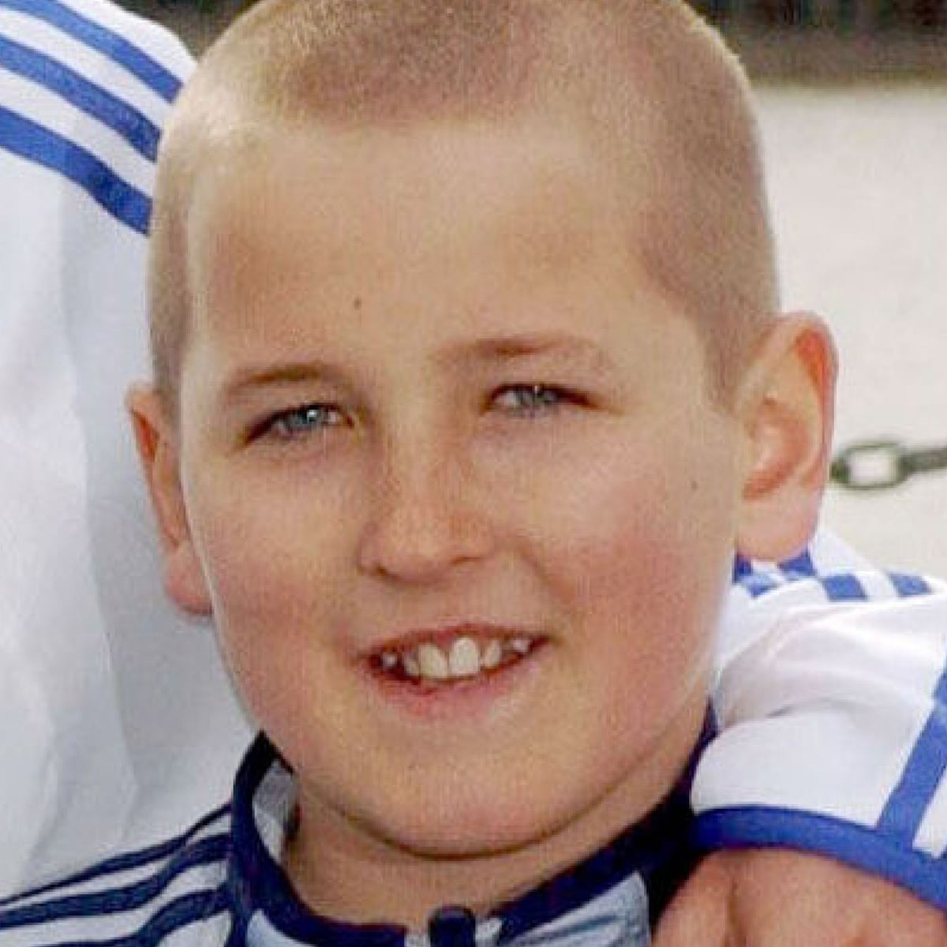

Activity 3: Spot the Differences between both pictures.
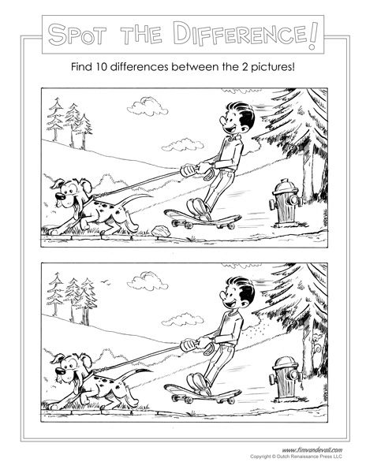

Activity 4: Art drawing: Drawing based on summer theme. The video tutorial guides you through a step by step process. Use the link:
https://www.youtube.com/watch?v=e8nlt_laK_0

Activity 5:
Catchphrase with a difference: Match the phrase to the character. I will do two examples.
Eh what’s up Doc | Bugs Bunny
D’oh | Homer Simpson
You are the weakest link goodbye
The chase is on
Bazinga
Eat my shorts
‘How you doin’
Yabba dabba doooo
Hasta la vista baby
Is that your final answer

Activity six: Name Character and Film.
Quote | Character | Film
Love is putting someone else’s needs before yours
There is no place like home
Have courage and be kind
To infinity and beyond
Oh yes the past can hurt but you can either run from it or learn from it
I’m big and you’re small, I’m right and you’re wrong and there is nothing you can do about it.
Only an act of true love can thaw a frozen heart
Merry Christmas you filthy animal…and a happy new year.
Hey Mr Wilson
I don’t believe it

Activity Seven: Must see Attractions: Match to their county
